Waterless Frenching
Waterless Lamb Frenching Production Prototype (Stage 3)
Project code  2025-1048 | Prepared by  Jack Hercus | Date submitted  05/03/2025
 | Published by  XXXXXXX | Date published  XX/XX/XX

Contents
Contents 2
1.0 Abstract 4
2.0 Executive summary 4
3.0 Introduction 5
4.0 Project objectives 5
5.0 Methodology 7
Beta Prototype Development and Testing 7
Design and Manufacture Production Prototype 10
Production Prototype Testing 11
Intercostal Quality Improvements 14
6.0 Results 17
7.0 Discussion 19
Repeatability 19
Durability 20
Commercial Viability 20
8.0 Conclusions 22
9.0 Recommendations 23
Further Development of a Next‑Generation Machine 23
Pathway Toward Full Conversion to Automated Waterless Frenching 23
10.0 Project outputs 23
Prototype Development Outputs 23
Testing and Data‑Collection Outputs 24
Industry Engagement Outputs 24
Project Documentation Outputs 24
11.0 Bibliography 24

Abstract
This project was undertaken to find a safer and more sustainable way to french lamb racks. Many processing plants rely on people using knives to clean the rib bones, which involves thousands of repetitive knife movements every day. This creates a high risk of strain injuries and cuts. Some plants use water‑based systems instead, but these are not suitable everywhere due to water use, waste disposal issues, and added operating costs. The goal of this project was to develop an automated, water‑free machine that could perform this task consistently, safely, and efficiently.
The project involved improving an earlier prototype, building a new full‑scale machine, and testing it in commercial processing plants. The team redesigned key components, trialled multiple versions, and ran the updated machine on thousands of lamb racks. They also worked with plant staff to test durability, speed, ease of cleaning, and day‑to‑day practicality.
The project achieved major gains. The automated system produced clean, well‑finished racks with very high consistency of up to 98.5% success in testing at double the speed of manual Frenching. It proved durable, easy to operate, and inexpensive to run. The main remaining challenge is that the machine does not yet produce intercostal meat in the same high‑value form as skilled workers, although a promising concept has been identified to resolve this issue.
For industry, the results show strong potential for safer work, reduced labour needs, more consistent product quality, and lower operating costs, especially for plants that do not currently recover high‑value intercostals.

Executive summary
This project aimed to develop and validate an automated, waterless lamb‑rack Frenching system as a safe, sustainable, and commercially viable alternative to manual knife Frenching and water‑based Frenching systems. Manual Frenching requires over 21 knife actions per rack or 210,000 per shift across the 10 operators (21 knife actions per rack x 10,000 racks) in a 10‑carcase‑per‑minute facility. This creates significant risks of repetitive‑strain injury (RSI) and lacerations. Water frenching systems, while effective, are unsuitable for many Australian processors due to water‑supply limitations and trade‑waste impacts. Building on earlier AMPC‑funded Alpha and Beta prototypes (projects 2023‑1020 and 2024‑1020), this project sought to refine the concept, improve repeatability, and design a robust Production Prototype capable of extended plant‑floor testing.
Key objectives included improving Beta Prototype repeatability, developing a Production Prototype that is easy to clean and maintain, enabling adjustable Frenching lengths, validating throughput and labour savings, and demonstrating commercial viability. The project also targeted high repeatability (≥95%), minimal damage rates (≤0.5%), and simple operation suitable for multi‑unit production‑line deployment.
The project progressed in three stages: Beta Prototype refinement, design and manufacture of a Production Prototype, and plant‑floor trials in Australia. Prototype performance improvements began with the development of a new cutting‑head design, tested extensively using rapid‑prototyping methods such as 3D‑printed variations. Trials were conducted in both New Zealand and Australia, processing hundreds of racks to fine‑tune the design.
A major early issue was identified in the cutting‑wire durability. This was solved through a continuous wire‑feed system that automatically replenishes filament before fatigue‑related failure occurs. Insights from these trials informed the design of the Production Prototype, which incorporated wash‑down‑resistant construction, increased throughput capability, industrial‑grade components, and a continuous process flow.
The refined Beta Prototype achieved 99% repeatability, and the Production Prototype achieved 98.5% repeatability across 200 racks. It appears that the remaining 1.5% of repeatability challenges have been resolved through software refinements, with updated testing showing no breakages; however, further validation on smaller spring‑season racks is required.
Throughput targets were exceeded, with the system achieving 4 racks per minute, double the manual rate, while occupying less than 1 m². Durability was strong, with no wire failures after implementing the continuous feed system and only one non‑design‑related mechanical fault over four months.
However, testing revealed a major commercial limitation: the intercostal product removed by the automated system is of significantly lower value than manually produced intercostal “fingers” creating an estimated $0.80 per carcass loss, which may outweigh labour savings in plants that currently recover high‑value intercostals. A potential solution to this has been conceptualised with strong potential to resolve this issue.
The automated system offers several industry‑wide advantages:
- Improved worker safety by eliminating high‑risk repetitive knife work.
- Labour efficiency, with the potential to halve labour requirements for Frenching processes.
- Superior consistency in Frenching finish and length, enabling potential yield gains.
- Low operating costs, with minimal power usage and inexpensive cutting filament.
- Scalable modular deployment suitable for plants aiming to automate without major footprint increases.
For processors that currently do not recover intercostal fingers, or those using water Frenching, the existing prototype is already likely to be commercially viable. With further development of the two‑stage intercostal removal system, the solution has strong potential to become widely viable across the Australian red‑meat industry.

Introduction
The purpose of this research project was to develop an automated waterless frenching solution as a safe and sustainable alternative to frenching with water or knives. In Australia, most processing facilities rely on operational staff with knives to undertake this activity. There are instances in Australian plants using the McLaren Stainless water frenching solution. Although this solution works well it is not suitable for all Australian locations due to the water usage, water source, and resulting additional trade waste load with the product (intercostals) and water being discharged to drain. Each 8-rib rack requires at least 21 knife actions (and up to 23), this activity results in up to 210,000 knife actions per operational staff member within a plant operating at 10 carcases per minute. This task has both a WHS repetitive strain and knife laceration safety concern.
Under the previously completed projects 2023-1020 and 2024-1020, Curious Creations Ltd was supported by AMPC to produce Alpha and Beta prototypes to test and refine the waterless automated frenching method that Curious Creations Ltd had conceptualised. This project seeks to build on that progress by improving the repeatability of the concept and then developing a Production Prototype to enable extended testing in a production processing environment.

Project objectives
- Improve the repeatability of the Beta Prototype so that:
  - 90% of the lamb racks that are processed by the prototype are in a condition ready for sale, and;
  - the remaining 10% of the lamb racks require some manual removal of intercostal meat to be in a condition ready for sale, and;
  - less than 1% of lamb racks are damaged by the prototype (i.e. broken bones).
- Design and produce a Production Prototype that incorporates findings from the Beta Prototype testing and is easy to install, operate, maintain and clean with:
  - design features that enable replacement of the cutting wires in under 5 minutes.
  - design features that enable replacement of the cutting blades in under 10 minutes.
  - easy access to all areas that come in contact with product for cleaning.
- Design and produce a Production Prototype that has design features that enable an adjustable frenching length between 40mm and 70mm, and the processing of lamb racks with a bone/cap thickness of 6mm to 20mm.
- Carry out Production Prototype trials to validate that a production system will be a commericially viable alernative to manual frenching by:
  - confirming that a single Production Prototype module can achieve a throughput of 2 racks/min, while taking up less floor space than manual frenching methods.
  - confirming that the Production Prototype is simple to operate, and multiple Production Prototype modules could be operated as a production system by a single operator in a production setting.
  - confirming that the anticipated labour savings of a production system will offset the operating cost of a production system.
- Carry out Production Prototype trials to test and validate the repeatability of the process so that:
  - 95% of the lamb racks that are processed by the Production Prototype are in a condition ready for sale, and;
  - the remaining 5% of the lamb racks require some manual removal of intercostal meat to be in a condition ready for sale, and;
  - less than 0.5% of lamb racks are damaged by the prototype (i.e. broken bones).
- Display to industry for feedback at AMPC Showcase September 2025.

Methodology

Beta Prototype Development and Testing
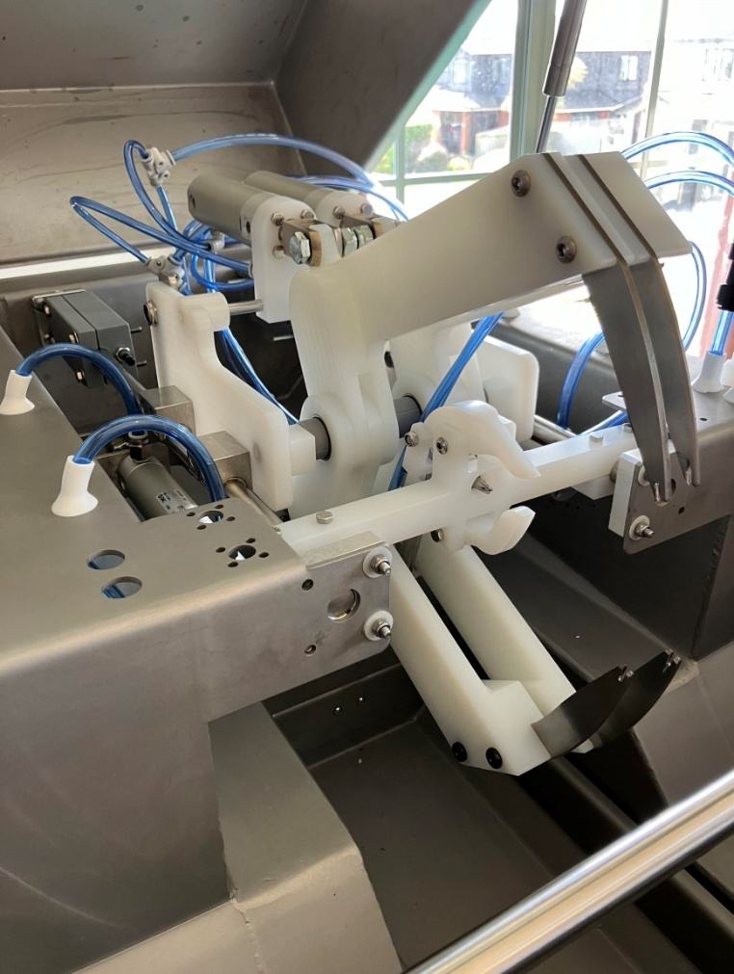
The first stage of this project was to improve the performance of the Beta Prototype that was previously produced under project code 2024-1020. A new cutting head was conceptualised that was expected to drastically improve the repeatability of the Beta Prototype in comparison to the previous design. This was demonstrated to AMPC representatives with a 3D printed concept. Multiple variations of this cutting head were produced utilising 3D printing to enable rapid prototyping, testing, and development to be conducted. A final version of the cutting head was then produced utilising traditional manufacturing methods. The body of the ‘flossing’ head was machined from food grade nylon and new cutting blades were produced from heat treated stainless steel. The completed cutting head is displayed in Figure 1.
Figure 1: Upgraded Beta Prototype cutting head
The upgraded cutting head was then tested in a NZ processing facility. Testing was conducted over a 5-day period with day 1 utilised for setup and site induction, day 2 for testing, day 3 for data review and adjustments, day 4 for further testing, and day 5 for pack up and data compilation. A room adjacent to the main processing area was utilised for the trial with unfrenched lamb racks collected from the production line as required. The setup of the Beta Prototype in the processing area is displayed in Figure 2.

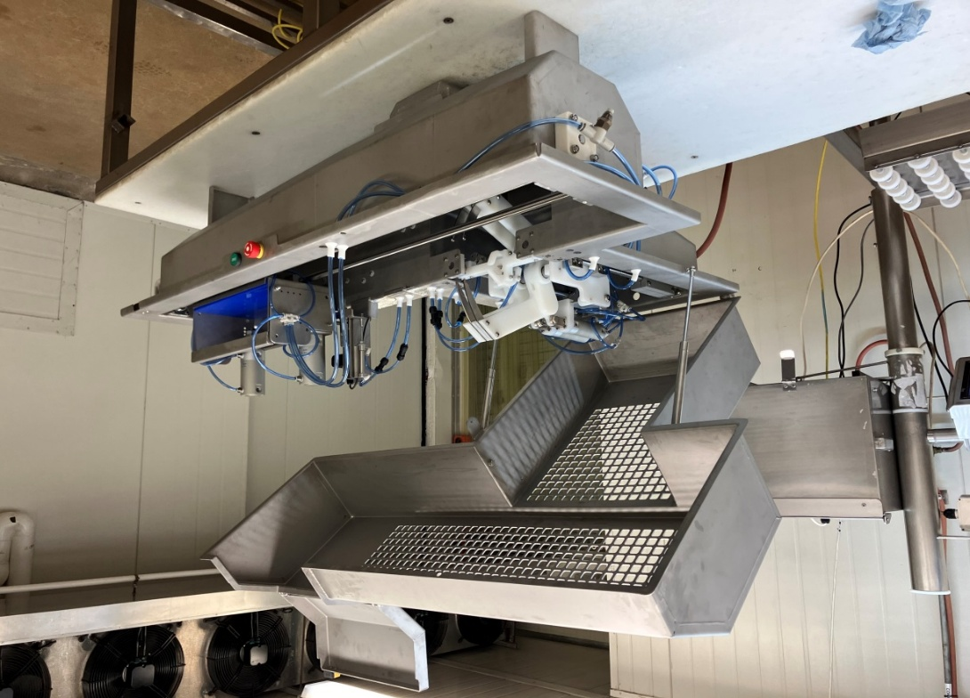
Figure 2: Upgraded Beta Prototype in Processing Plant
The Beta Prototype was setup for cap-off, 100mm bone length, 35mm frenching length specification as this is what the rest of the processing facility was producing which enabled the test racks to be exported. Plastic wrapping was added to the prototype to protect the components that were not resistant high pressure water spraying as the prototype was vigorously cleaned by the site cleaning staff overnight. These would need to be shrouded within the body of the machine in a commercial solution.
115 racks were frenched on the first day of testing with adjustments made to various settings to optimise the finish achieved and the repeatability. Numerous types of cutting wires were trialled to determine the cutting performance and lifespan of the wires. Unfortunately, the cutting wires did not last as long as hoped with the best configuration achieving only 36 racks. In general, it was found that wires of greater flexibility had the longest life span and the wire strands appeared to fail due to the metal fatigue associated with the flossing action rather than abrasive wear. It is likely that the wire life could be increased with further optimisation, however significant improvement would be required to achieve a commercially viable life span when up to 1200 racks could be processed by a module in a 10-hour shift.
It was agreed by all stakeholders that the wire life span issue should be resolved before the Beta Prototype was tested in Australia. To solve this, a continuous wire feed system was conceptualised that would gradually replace the wires before they began to fail. Numerous 3D printed concepts were developed and tested until a suitable solution was identified. The implemented continuous wire feed system is shown in Figure 3. It utilised a roll of stainless-steel wire and gradually feeds this through the cutting head before the wire begins to fail.

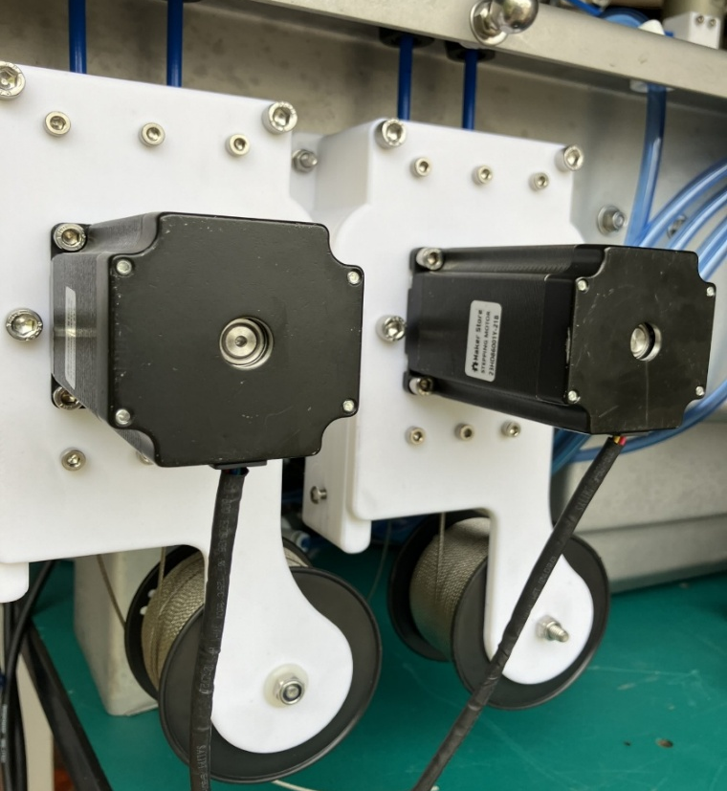
Figure 3: Continuous wire feed system
A suitable Processing Facility was identified with assistance from AMPC, and the Beta Prototype was crated and sent to Australia for testing. A two-week testing window was allocated in February 2025 to allow for sufficient testing, site induction, machine setup and travel. The Beta Prototype was setup in the main lamb processing room adjacent to the line where the manual Frenching was occurring. The setup of the Beta Prototype in the Australia processing facility is shown in Figure 4.
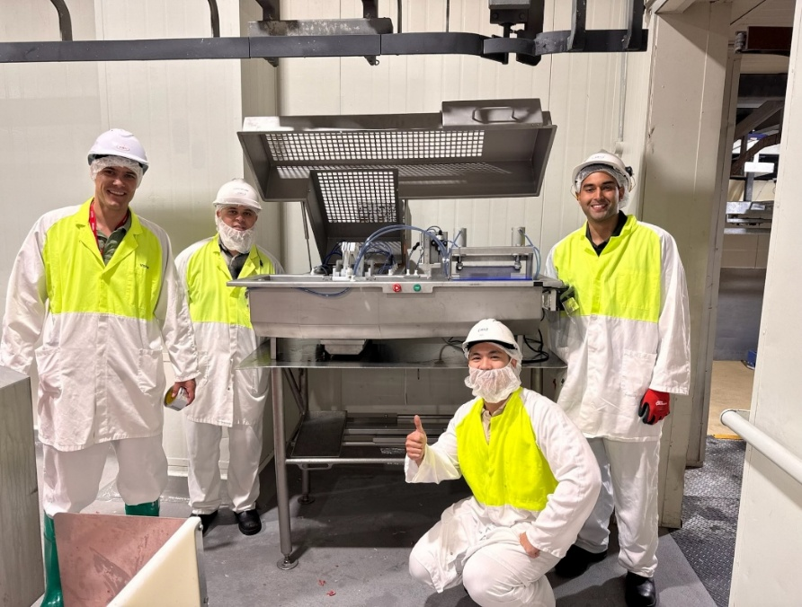
Figure 4: Beta Prototype setup in Australia processing facility

On the first day of testing, 204 lamb racks were processed by the Beta Prototype to measure the repeatability of the process on Australian Lamb. Of the 204 lamb racks tested, there were only two that required additional manual intercostal removal to meet the required standard to be suitable for sale which results in a repeatability rate of 99% (2 out of 204). One of these was due to the inadequate clamping of the rib bones which resulted in the sensor not adequately detecting the location of the bones, and the other was due to a large lump on the animal’s rib bone, likely caused by being broken and healed, which resulted in a large bone lump that the cutting wires could not slide over.
Testing of the Beta prototype continued in the Australian processing plant over the two-week testing window with numerous findings identified which then contributed to the design of the new Production Prototype.

Design and Manufacture Production Prototype
A Production Prototype was designed that incorporated the findings of the Beta Prototype testing, and sought to meet the project repeatability objectives. Key improvement areas of this design over the Beta Prototype included:
- Washdown resistant components and structure
- Free standing
- Increased throughput
- Continuous process (operator does not need to unload frenched racks)
- Robust industrial components designed for high cycle operation
The completed design of the Production Prototype is displayed in Figure 5.
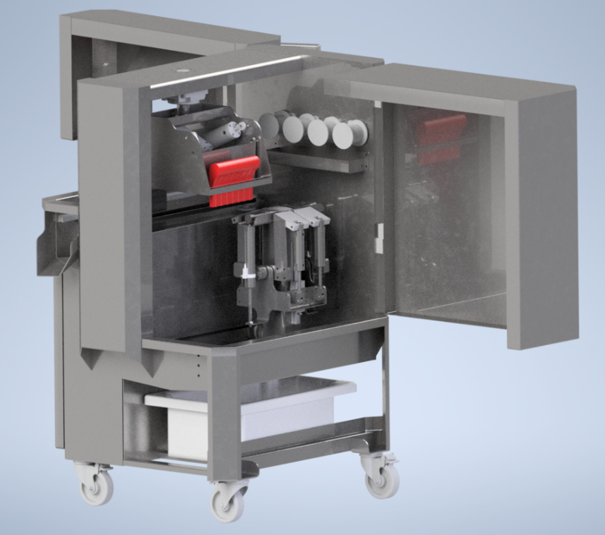
Figure 5: Production Prototype design

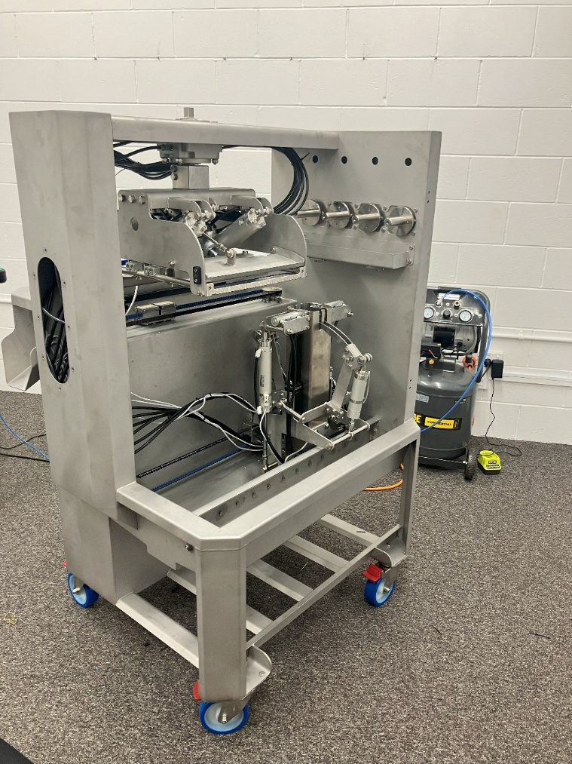
The Production Prototype was then manufactured according to the design as displayed in Figure 6.
Figure 6: Production Prototype Manufacture

Production Prototype Testing
The Production Prototype was freighted to a processing facility in Australia and installed adjacent to the current manual Frenching operation. This enabled efficient testing where lamb racks could be taken directly from the production line for testing. The trial setup is displayed in Figure 7.

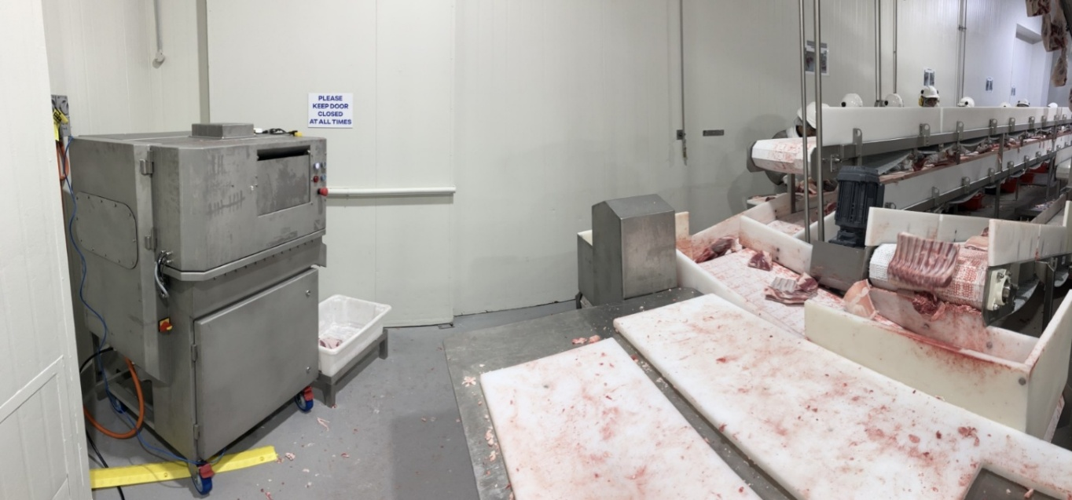
Figure 7: Production Prototype Trial Setup
Initially some adjustments were required to the Prototype to improve its repeatability on Australian lamb racks. This was because the bones of the racks were wider and further spaced apart than those in NZ. Additionally, the Australian racks contained more meat and fat with a different weight distribution which impacted the way that they ejected from the machine. These adjustments were made over the first 3-4 days of testing with the on-site 3D printer utilised to trial various improvements.
Eventually the performance of the Prototype reached a satisfactory level to enable repeatability testing to be carried out. Two trials of 100 lamb racks were conducted, with the first over a carcass weight range of 16-25kg, and the second over a weight range of 26-40kg. During the trial the Frenching finish was carefully monitored to capture any racks that had an unsatisfactory result. Figures 2 and 3 display a sample of the satisfactory Frenching finish across the two weight classes that were tested.
Eventually the performance of the Prototype reached a satisfactory level to enable repeatability testing to be carried out. Two trials of 100 lamb racks were conducted, with the first over a carcass weight range of 16-25kg, and the second over a weight range of 26-40kg. During the trial the Frenching finish was carefully monitored to capture any racks that had an unsatisfactory result. Figure 8 displays a sample of the satisfactory Frenching finish across the two weight classes that were tested.
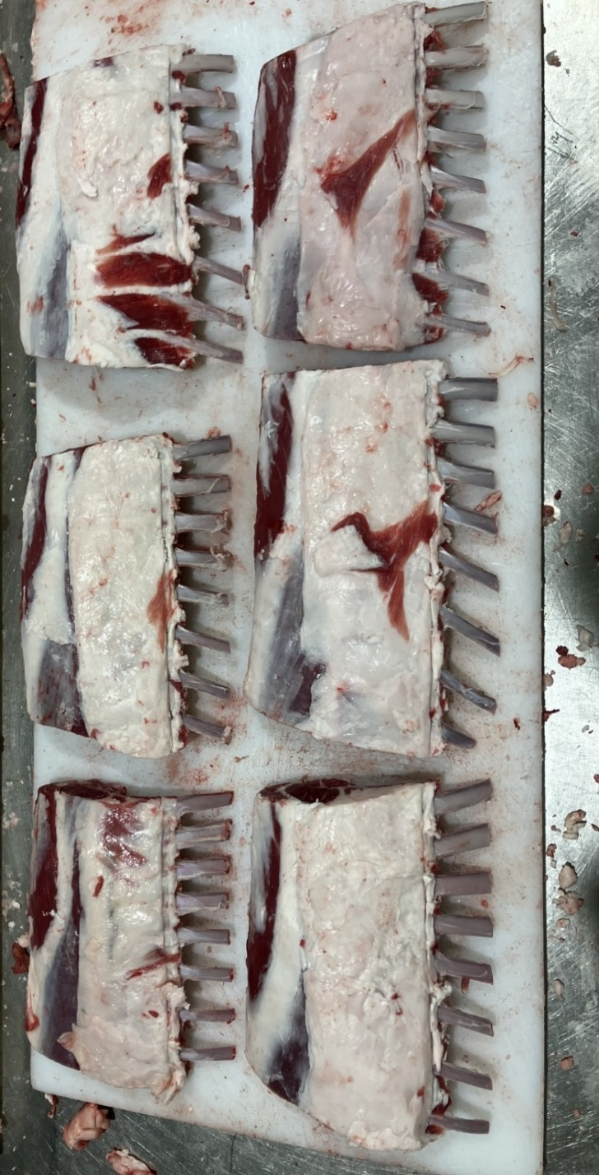
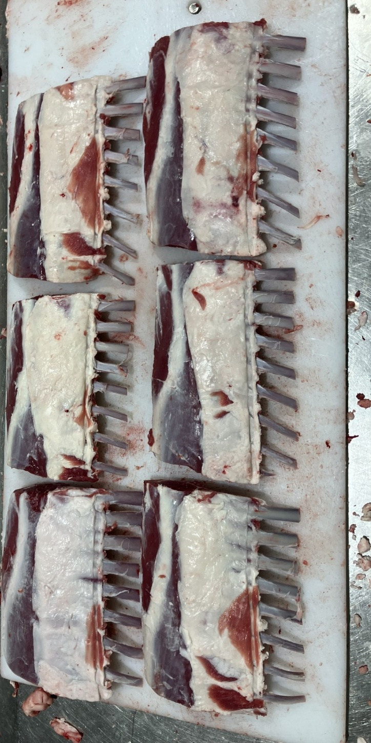
Figure 8: Sample of satisfactory frenching finish.
Across the test run of 200 lamb racks, the system achieved 98.5% repeatability (197 successful racks). The only failures were two snapped small rib bones in the 16–25 kg weight range and one incomplete frenching in the 26–40 kg range. The snapped ribs represent the more significant issue, as any rack that no longer meets the eight‑rib requirement is heavily discounted. The incomplete frenching is less critical because it can be corrected by rerunning the rack or finishing it manually. Figure 9 illustrates a rack with a snapped rib bone.

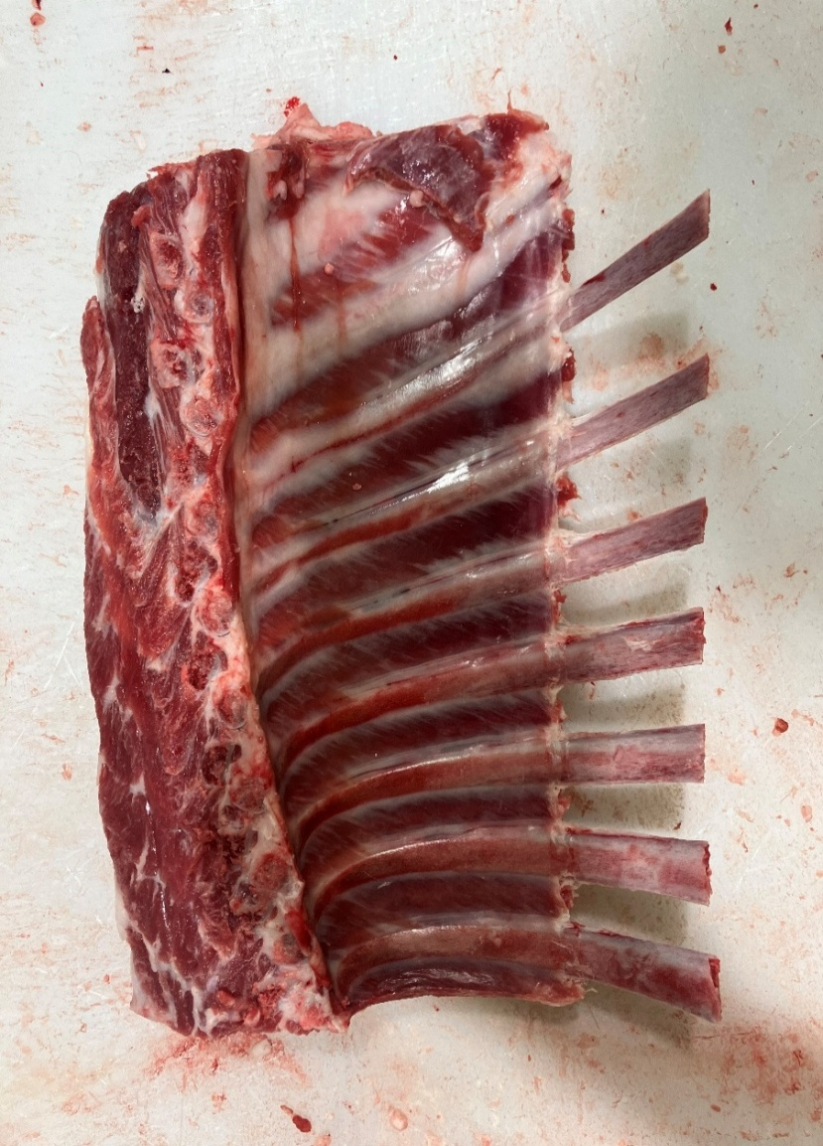
During the next testing phase, the Production Prototype was refined to address the broken rib bone issue. This refinement focused on enhancing the software to introduce an algorithm that adjusts stripping pressure based on the width of each rib bone. After implementing this update, the machine operated over several days without any further rib breakages; however, this testing occurred later in the season when lamb racks were larger. Additional early-season testing will therefore be required to confirm that the updated software also prevents breakages in smaller racks.
Figure 9: Snapped rib bone

Intercostal Quality Improvements
Another area of interest during the testing was the quality of the removed intercostal product. Plants which are currently manually Frenching remove the intercostal in a neat rectangular shaped portion. This fetches a premium price over standard trim and is typically sold into markets that produce skewers from the product. A sample of the intercostal trim from the prototype was captured during the trials to gain feedback from the sales staff at the processing site.
Figure 10 displays a comparison of the intercostal which is manually removed versus the intercostal that was removed by the prototype. The product is not the same due to the way in which the prototype strips the intercostal from the rib bone, resulting in scrunching and tearing. There is potential that the devaluing of this product could make the automated Frenching solution unviable due to the resulting loss in revenue.

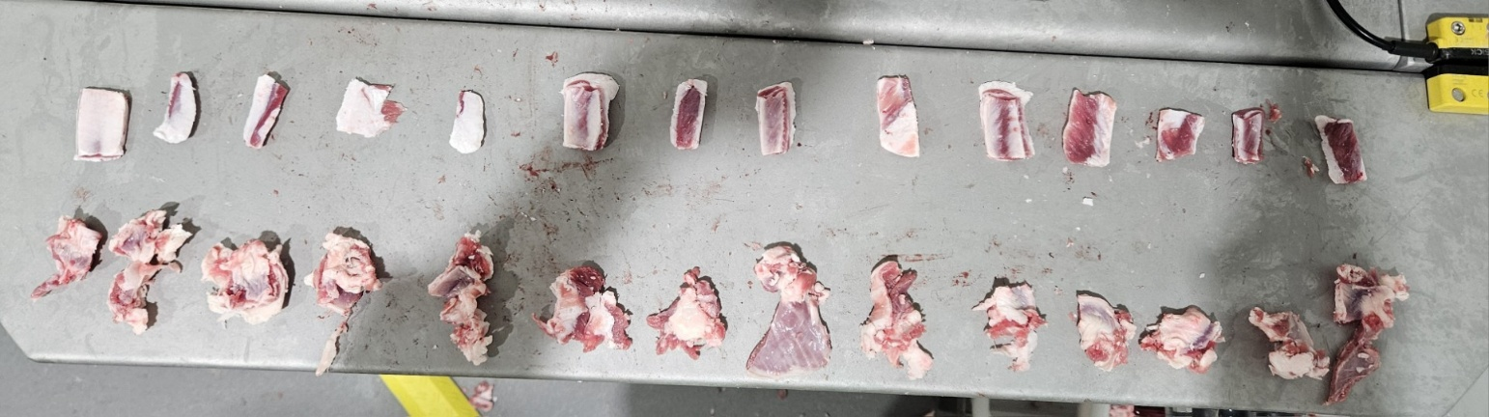
The removed intercostal also needs to be free of bone fragments, as their presence can trigger extra manual sorting or reduce the value of the intercostal product. Testing and development of the prototype has significantly reduced bone‑fragment occurrence through improvements to the pressure‑control algorithms used during stripping and refinements to the bone‑sensing system. Some fragments are still being removed from the lamb rack, and resolving these cases remains difficult. Figure 11 shows an example where part of the 9th rib has remained on the rack due to upstream process inaccuracies; the current stripping mechanism then removes this bone fragment along with the intercostal material, causing it to mix with the rest of the product.
Figure 10: Comparison of intercostal product after automated and manual removal.
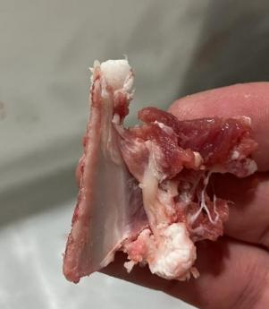
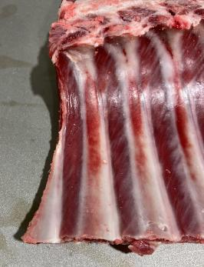
Figure 11: Bone fragments resulting from upstream process inacuracies

Several intercostal slicing concepts were rapidly prototyped and tested using low-cost development methods to explore potential design improvements to increase the quality of the removed intercostal.
An initial concept involved adding a fixed slicing blade to the existing stripping mechanism to reduce intercostal tearing and stringing. While this approach successfully eliminated stringing, it did not produce the clean, rectangular intercostal strips achieved through manual frenching. The intercostal material continued to bunch during the filament stripping process, limiting the overall improvement in product quality.
A second concept introduced an articulating slicing blade designed to move closer to the adjacent rib edge during stripping, with the aim of increasing strip size and improving definition. However, this configuration produced no meaningful improvement over the fixed blade. The articulation added mechanical complexity and reduced system reliability, while offering minimal functional benefit.
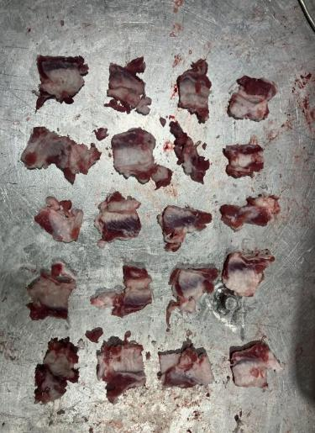
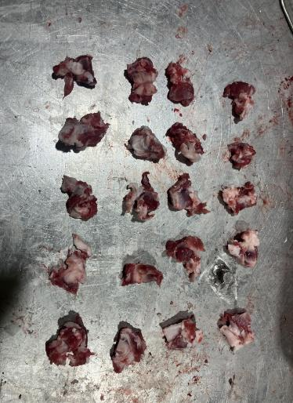
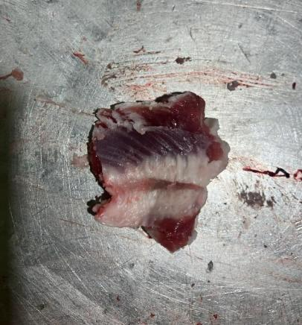
Although both slicing approaches reduced stringing, neither achieved the desired strip quality, largely due to the inherent behaviour of the filament stripping process. Additionally, neither concept resolved issues related to bone fragment contamination, and further refinement of the existing system is unlikely to fully address this limitation. The resulting intercostal that was produced from these developments is displayed in Figure 12 with the pieces of intercostal displayed in both the scrunched state as they come off the machine, and in the unfolded state.
Figure 12: Optimised intercostal from single stage removal showing both as removed and unfolded state.

Following the limited success of the slicing blade developments, it was hypothesised that the challenges which were experienced could be resolved through the introduction of a two-stage intercostal removal process. This would seek to slice the intercostal strips from between the rib bones in a similar manner to the manual process, before stripping the remaining tissue surrounding each bone with the existing mechanism.
Implementation of a two-stage intercostal removal system is not possible on the existing prototype due to the physical size constraints of the machine. However, the theory of the two-stage system could be tested by first configuring the prototype with a slicing mechanism, processing a number of lamb racks, and then reconfiguring the prototype with the existing stripping mechanism and reprocessing the same racks. Figure 13 shows the lamb racks and intercostal after both the 1st and 2nd stage of removal.
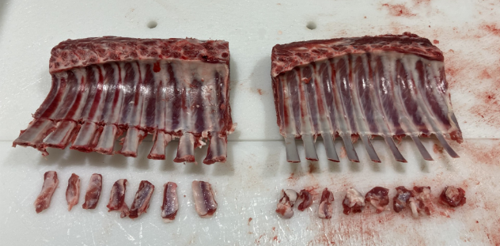
Figure 13: Conceptualised two-stage intercostal removal method.
The two-stage intercostal removal solution offered two key benefits over the single stage mechanisms that were trialled. Firstly, it can produce intercostal product that is of the same form as that produced during manual frenching. Additionally, the 1st stage slicing mechanism has a much lower likelihood of introducing bone contamination into the intercostal product as it does not impart the same mechanical force on the rib bones. A suitably configured two-stage frenching system could separate the 1st and 2nd stage intercostal product to first cut the desired neat strips from between the bones, and then strip the remaining tissue around the bones as a scrunched product.

Results
Table 1 displays the results that were achieved against the Project Objectives.

Table 1: Results mapped against Project Objectives
Objective | Result | Comment
Objective 1: Improve the repeatability of the Beta Prototype so that:
90% of the lamb racks that are processed by the prototype are in a condition ready for sale, and; | Achieved | Repeatability of 99% achieved (202 out of 204)
the remaining 10% of the lamb racks require some manual removal of intercostal meat to be in a condition ready for sale, and; | Achieved | Repeatability of 99% achieved (202 out of 204)
less than 1% of lamb racks are damaged by the prototype (i.e. broken bones). | Achieved | No broken bones during Beta Prototype repeatability test
Objective 2: Design and produce a Production Prototype that incorporates findings from the Beta Prototype testing and is easy to install, operate, maintain and clean with:
design features that enable replacement of the cutting wires in under 5 minutes. | Achieved | Cutting wire is continuously and automatically replenished while in use.
design features that enable replacement of the cutting blades in under 10 minutes. | Achieved | Cutting blades are able to be replaced in <10 mins, however there is no requirement to routinely remove the blades.
easy access to all areas that come in contact with product for cleaning. | Achieved | Production Prototype was installed in plant for 4 month period and successfully cleaned between uses.
Objective 3:
Design and produce a Production Prototype that has design features that enable an adjustable frenching length between 40mm and 70mm, and the processing of lamb racks with a bone/cap thickness of 6mm to 20mm. | Achieved | Adjustable backstop enables frenching length to be changed from 40-70mm. Both Cap-on and cap-off lamb racks were successfully processed.
Objective 4: Carry out Production Prototype trials to validate that a production system will be a commericially viable alernative to manual frenching by:
confirming that a single Production Prototype module can achieve a throughput of 2 racks/min, while taking up less floor space than manual frenching methods. | Achieved | Throughput of 4 racks/min achieved with machine footprint of 1m x 0.9m. See Discussion section for further detail.
confirming that the Production Prototype is simple to operate, and multiple Production Prototype modules could be operated as a production system by a single operator in a production setting. | Achieved | The intuitive loading system and automatic unloading of frenched racks results in simple system. See Discussion section for further detail.
confirming that the anticipated labour savings of a production system will offset the operating cost of a production system. | Partially Achieved | See Discussion section for further detail.
Objective 5: Carry out Production Prototype trials to test and validate the repeatability of the process so that:
95% of the lamb racks that are processed by the Production Prototype are in a condition ready for sale, and; | Achieved | Production Prototype achieved repeatability rate of 98.5%.
the remaining 5% of the lamb racks require some manual removal of intercostal meat to be in a condition ready for sale, and; | Achieved | Production Prototype achieved repeatability rate of 98.5%.
less than 0.5% of lamb racks are damaged by the prototype (i.e. broken bones). | Partially Achieved | 1% of lamb racks (always the smallest) were damaged by the prototype in initial testing. This was potentially resolved through a software update during further testing, but results are not conclusive as the lamb racks were also larger as this testing was conducted later in the season.
Objective 6:
Display to industry for feedback at AMPC Showcase September 2025. | Achieved

Discussion

Repeatability
The developments delivered in this project have significantly improved the repeatability of the waterless lamb Frenching solution. Under project 2024‑1020, a repeatability level of 86% was achieved over a 50‑rack trial. In comparison, the Production Prototype produced under this project achieved a repeatability rate of 98.5%.
The remaining 1.5% consisted of a 1% occurrence of broken bones and a 0.5% occurrence of insufficient Frenching. The 1% rate of broken bones is particularly significant, as lamb racks that do not meet the 8‑rib specification are substantially devalued.
Further work was undertaken to address this issue through updates to the machine software. Initial testing indicates that the issue has been resolved, which would increase the repeatability level to 99.5%. However, additional testing on the smaller lamb racks typically produced in spring is required to verify these results.

Durability
An outstanding question at the conclusion of project 2024‑1020 concerned the durability of the cutting wires used to complete the Frenching process. This issue has now been resolved through the implementation of a wire‑feed system that continuously replenishes the wire before it begins to fail. With this system installed on the Production Prototype—along with the selection of an optimal filament—there have been no further instances of wire breakage during operation.
The general durability of the Production Prototype has also proven to be strong. Only one mechanical failure occurred during the four‑month testing period, and this was traced to a software bug that caused the machine to malfunction rather than any mechanical design weakness.

Commercial Viability

Potential Labour Savings
The Production Prototype achieved a throughput of 4 lamb racks per minute with a footprint of 0.9 m². For comparison, a person manually removing the lamb rack fat cap and then Frenching can process approximately 2 lamb racks per minute with a footprint of around 0.5 m².
It is envisaged that the optimal installation of the Production Prototype would involve a single operator removing the fat cap and then placing each rack directly into the automated Frenching machine, which would then eject the Frenched rack onto a product conveyor. This configuration removes the need for separate labour units to load the machine and would reduce the labour required for fat‑cap removal and Frenching by 50%.
For clarity, Figure 14 compares the current manual Frenching setup with the proposed future layout for a plant operating at 10 carcasses per minute.

1
2
3
4
5
6
7
8
9
Product Conveyor
10 people removing fat caps and Frenching
10
1
2
3
4
5
Product Conveyor
5 people removing fat caps and placing in Frenching machine
Frenching Machine
Frenching Machine
Frenching Machine
Frenching Machine
Frenching Machine
Figure 14: Comparison of current manual frenching layout to embodied Production Prototype arrangement.

In addition to labour savings, the automated solution would provide the following advantages:
- Elimination of RSI‑inducing wrist motions associated with manual Frenching.
- Improved Frenching finish, producing cleaner rib bones compared with manual processing.
- Greater consistency in Frenching length, creating an opportunity to increase lamb rack yield by minimising unnecessary Frenching length.
The operating costs of the Production Prototype are very low. The machine operates on a 10‑amp single‑phase power supply and compressed air. In addition, the system consumes the continuously replenished cutting filament at a rate of approximately 5 mm per lamb rack, equating to around 12 metres over a 10‑hour shift in which each machine processes approximately 2,400 lamb racks. The cutting filament is low‑cost and readily available in commercial quantities at roughly $1 per metre.

Intercostal Value
A major disadvantage of the current automated Frenching solution is the quality of the removed intercostal product, which does not match the intercostal “fingers” produced through manual Frenching. As a result, the intercostal product generated by the automated system would likely need to be sold as trim. While prices for both intercostal fingers and trim vary, a reasonable estimate assumes that intercostal fingers command a $10/kg premium over standard lamb trim.
Testing has shown that approximately 40 grams of intercostal material is removed from each lamb rack. This equates to a reduction in intercostal value of approximately $0.40 per lamb rack, or $0.80 per carcass, when using the automated Frenching system. Based on this, the anticipated labour savings delivered by automation are unlikely to offset the loss in intercostal value.
However, discussions with various processors at the AMPC Innovation Showcase highlighted that not all processors capture intercostal fingers as a separate product. Some already collect it as trim, while others use water Frenching, which results in no intercostal recovery at all. For these processors, the existing automated Frenching solution is likely to be commercially viable, as the reduced intercostal value would not represent a material loss.

Opportunities for Improvement
A potential solution to the intercostal quality issue was identified during this project through the development of a two‑stage intercostal removal process. In this approach, the system would first slice the intercostal “fingers” from between the rib bones before stripping the remaining intercostal material surrounding each bone. This method would maintain the high‑quality Frenching finish already achieved by the Production Prototype while also enabling recovery of the higher‑value intercostal fingers.
There is also considerable potential to increase the throughput of the automated Frenching solution. The Production Prototype currently uses pneumatic actuators to remove the intercostal material from each rib bone. While ideal for prototyping due to their simplicity and controllability, pneumatic systems are relatively slow. Converting the cutting head to be driven by an electronic servo motor would significantly increase processing speed.
Further gains could be achieved by optimising the overall system layout. The current Production Prototype includes several points at which components need to stop, reverse direction, or pause while safety interlocks are confirmed. Streamlining these interactions would further improve throughput.

Conclusions
This project set out to create a safe, reliable, and water‑free alternative to manual lamb‑rack Frenching, and the results show that this goal is now within reach. The improvements made to the prototype delivered a major lift in performance, lifting consistency from earlier levels of around 86% to 98.5% repeatability in commercial plant trials. This indicates that the automated process can reliably produce sale‑ready racks with minimal rework and very low rates of product damage. In addition, updates to the software appear to resolve the small number of broken rib bones observed in early testing, suggesting the system may achieve repeatability levels approaching 99.5% once validated on smaller spring season racks.
The testing also demonstrated that the machine is reliable, durable, and cost‑efficient. Throughput reached 4 racks per minute, double the typical manual rate, and the continuous wire‑feed system proved highly reliable, with no breakages during extended operation. Combined with low power consumption and inexpensive filament, these results confirm that the ongoing running costs of the system are very low. Together, these findings show that the technology is suitable for continuous industrial use and can be integrated into existing production environments with minimal operator burden.
However, the results also highlight a key limitation for plants that generate revenue from high‑value intercostal “fingers.” The current machine removes intercostals in a lower‑value form, reducing potential product returns by around $0.80 per carcass. For processors who already treat intercostal as trim, or who use water‑frenching systems that do not recover intercostals at all, the automated solution is immediately commercially feasible. For others, resolving intercostal quality will be essential before broad industry adoption is viable.
Importantly, the project identified a promising pathway forward through a two‑stage intercostal removal system, which early testing showed can produce intercostal strips similar to those removed manually. This provides a strong direction for future development and may allow the system to achieve both high throughput and high intercostal value in a next‑generation design.
Overall, the project confirms that automated waterless Frenching can deliver significant benefits to the red‑meat industry, including safer work practices, reduced labour needs, consistent product quality, and low operating costs. Further development focused on intercostal quality and continuous‑flow machine architecture will support wider commercial adoption and ensure the technology meets the needs of a broader range of processing businesses.

Recommendations

Further Development of a Next‑Generation Machine
- Proceed with the design and build of a new machine that incorporates the two‑stage intercostal removal approach. This next‑generation system should aim to deliver both high‑quality intercostal product and increased throughput, overcoming the main remaining barriers to commercial adoption.
- Conduct further testing to validate performance across all seasonal carcass variations, particularly smaller early‑season racks, to ensure bone‑breakage risk is fully eliminated.

Pathway Toward Full Conversion to Automated Waterless Frenching
- Develop an adoption roadmap that outlines how a plant could progressively transition from manual or water‑based Frenching to automated waterless Frenching, including workflow changes, operator training, and integration with fat cap removal stations.
- Work with processors to identify a suitable plant for a full‑line conversion trial, once the next‑generation machine is validated.
- Prepare practical extension materials simple operator guides, case studies, product comparisons to support industry understanding of the benefits and requirements of adopting automated Frenching.

Project outputs

Prototype Development Outputs
- Improved Beta Prototype
  - Redesigned cutting‑head assembly
  - Integration of an automated continuous wire‑feed system
  - Successful installation and testing in New Zealand and Australian processing plants
- Production Prototype Machine
  - Full mechanical and electrical design package
  - Wash‑down‑ready construction and industrial‑grade components
  - Continuous‑process layout with automated unloading
  - Adjustable Frenching‑length mechanism (40–70 mm)
  - Completed fabrication, assembly, and bench testing
  - Delivery, installation, and commissioning in an Australian processing plant

Testing and Data‑Collection Outputs
- Beta Prototype Trials
  - Five‑day testing program in New Zealand
  - Two‑week testing program in an Australian processing plant
  - Collection of repeatability, durability, and wire‑life data
  - Intercostal‑product sampling for quality assessment
- Production Prototype Trials
  - 5 weeks of testing and refinement in an Australian plant over a 4 month period
  - Structured repeatability testing
  - Comparative intercostal‑quality trials

Industry Engagement Outputs
- Demonstration at AMPC Innovation Showcase (September 2025)
- Prototype displayed to industry stakeholders
- Feedback gathered to inform next‑stage development

Project Documentation Outputs
- Full technical report documenting:
  - Prototype design evolution
  - Testing procedures and results
  - Performance metrics
  - Commercial and operational insights
  - Recommended future development pathway

Bibliography
Hercus, J. (2024) Waterless Lamb Frenching Prototype: Final Report 2024‑1020. Australian Meat Processor Corporation (AMPC), North Sydney. Available at: https://ampc.com.au/media/cuvbkuqk/final-report-2024-1020.pdf

