Mayekawa – Lamb and beef hindquarter leg deboning automation scoping
OPEN
Project code  2025-1038 | Prepared by  Fraser Border, Shinji Hane, Koorosh Khodabandehloo and Akira Taniyama | Date submitted  16/10/25
 | Published by  XXXXXXX | Date published  XX/XX/XX

Contents
Contents 2
1.0 Abstract 3
2.0 Executive summary 3
3.0 Introduction 4
4.0 Project objectives 5
5.0 Methodology 5
6.0 Results 6
7.0 Discussion 12
8.0 Conclusions 12
9.0 Bibliography 13
10.0 Acknowledgements 13

Abstract
This project was undertaken to address a critical challenge in the red meat processing industry focusing on the labour-intensive and physically demanding task of deboning.
The project has assessed lamb and beef boning processes, scoping relevant automation based on existing DAS equipment from Mayekawa.
Automation for lamb leg deboning is feasible and economically attractive. For beef legs new cutting and boning schemes more appropriate to DAS solutions from Mayekawa require further R&D.
More than 20 processors in Australia have kindly engaged with the project confirmed strong industry demand for both solutions.

Executive summary
The Australian red meat processing industry relies heavily on manual deboning of lamb and beef legs, a task that is physically demanding, costly, and highly variable in both quality and yield. The main problem addressed was the risk of repetitive strain injuries to workers, the high cost of labour, and the difficulty of achieving yield results with consistency using manual deboning. This project has provided a new initiative for a world-first automation solution specifically for lamb and the pathway for the same for beef leg deboning. The work has shown potential to deliver solutions with measurable financial, efficiency, and safety benefits for the Australian red meat industry.
Objectives
The project objectives as originally defined aimed to:
- Benchmark lamb and beef leg deboning practices and variability.
- Assess the potential of existing Mayekawa leg deboning technologies (TAKIDAS, HAMDAS, CELLDAS) for lamb and beef applications.
- Prototype and test modifications for lamb legs to define a Lamb Leg Deboning Machine (LALDAS).
- Scope technical feasibility and define pathways for a Beef Leg Deboning Machine (BELDAS)
Methodology followed
All objectives have been met, with LALDAS progressing to further development under a new AMPC project and BELDAS defined for future R&D. The Mayekawa team have efficiently executed: -
- site visits to lamb and beef plants to document manual deboning,
- video recorded and analysed cutting and deboning,
- conducted trials using the TAKIDAS machine (designed for turkey) with lamb legs, including iterative prototyping and testing of modified modules,
- mapped beef deboning processes against pork deboning steps in HAMDAS and CELLDAS,
- engaged with processor, including over 20 Australian companies at IFFA and AMPC Showcase events.
Results/Key Findings
- LALDAS (lamb) is feasible and offers measurable benefits potentially offering a 30-month ROI.
- BELDAS (beef) is feasible in principle but requires further R&D, particularly in sensing and robotic manipulation.
- Australian processors who have expressed strong interest, will have an important role with Mayekawa defining a clear commercial pathway for these developments and future adoption.
Benefits to Industry
The adoption of automated lamb and beef leg deboning machines will reduce labour costs, improve yield and product consistency, and lower the risk of repetitive strain injuries. These outcomes directly support workforce sustainability, productivity, and profitability for processors and levy payers.
Future Research and Recommendations
The next steps will complete the development of LALDAS by Mayekawa and demonstration of the first world prototype in Australian plants. Continued engagement with processors is to provide input as well as pathways for R&D in Beef and lamb deboning Automation to reach industry adoption.

Introduction
The Australian red meat processing industry faces significant challenges relating to labour costs, worker safety, and the availability of skilled staff. One of the most pressing issues is the manual deboning of lamb and beef legs, a task that requires high skill, is physically demanding, and contributes heavily to repetitive strain injuries and other musculoskeletal disorders. Manual deboning is also costly and variable, with yield and product consistency depending on the experience and condition of individual workers. Reports confirm that musculoskeletal disorders are common among slaughterhouse workers, particularly in repetitive upper-limb tasks such as deboning (Science Forecast, 2018; Safe Work Australia, 2019).
Automation has been widely applied in many parts of food production, but the adoption of robotics in meat processing lags other sectors. Deboning presents technical hurdles because carcasses vary in size and shape, and the separation of meat and bone requires precision, dexterity, and adaptive sensing (Bogue, 2009; Jelenkovic et al., 2020; Aly et al., 2023). Existing robotic systems for poultry and pork deboning have demonstrated potential, but their direct transfer to lamb and beef has been limited because of anatomical differences and the larger variability of primals (Frontiers, 2025). This creates a clear knowledge gap and a need for solutions tailored to the Australian red meat sector.
The results of this research will be used to guide the development of demonstration machines, ensuring that processors can access technologies that reduce labour costs, improve product consistency, and yield, and enhance workplace safety. For levy payers, the outcomes represent a clear return on investment by addressing one of the most difficult and costly problems in meat processing with world-first automation tailored to Australian industry needs.

Project objectives
The objectives of this project were:
- Benchmark and process evaluate Lamb and Beef de-boning practices, leg primal variability, and muscle-bone separation sequence as compatible with TAKIDAS and HAMDAS/CELLDAS equipment.
- Assess TAKIDAS features for relevance to Lamb Leg Deboning and redefine, as appropriate, the configuration of a Lamb Leg deboning steps and engineering modifications mapping the requirements of Australia Processors. This would result in a Lamb leg deboning unit (LALDAS).
- Assess HAMDAS/CELLDAS process for Beef leg deboning establishing the steps that could result in a similar outcome as that for Lamb, defining a future project towards a solution for beef as BELDAS.
- Quantify value proposition based on practical assessments of user processes as current practices and the projected performances of future DAS machines for Lamb and Beef.
- Report on findings and value proposition, with detailed planning for the next steps towards demo machines of the future.

Methodology
The following approach was undertaken for this project:
- Initial benchmarking of process and deboning processes with Australian Lamb and Beef processors.
- Establishing a formal user process definition and automation requirements with respect to cutting sequences and performance expectations in efficiency, yield and quality.
- Mapping of the current cutting steps in Lamb and Beef processes with the Mayekawa DAS machines already in operation.
- Experimental assessment with Lamb involving practical trials with current DAS equipment such as TAKIDAS and evaluation of the process based on technical studied and mapping of the beef process with those that are performed by HAMDAS/CELLDAS, highlighting all aspects change in mechanical and sensing features that would provide potential solution for beef leg deboning. The results will include:
- In the case of Lamb, video recordings of testing with TAKIDAS as an experimental set up with modified features for Lamb.
- In the case of beef, pictorial representations of the steps of separation and graphical presentation of the process as envisaged by HAMDAS or CELLDAS.
- Consideration of development or change in design as well as integration of the respective devices in a detailed future R&D initiative to reach working machines for beef and lamb, based on the findings, also including specification of any relevant work in AI and learning optimisation processes.
- Documentation and report on findings.
- Video recordings of practical tests and trials with equipment.
- Drafting of future R&D with timelines and resources with recommendations beyond the scoping work of this proposal.

Results
This project delivered results across six milestones, progressing from benchmarking and trials to processor engagement and value proposition analysis. The outcomes demonstrate the feasibility and benefits of automated deboning solutions for both lamb and beef legs.
Stage 1: Benchmarking and Product Variability through Site Observations
Visits were conducted to multiple Australian beef and lamb processing plants, including 2 beef plants (A and C) and two Lamb Plants (B and C).

- Video documentation captured step-by-step deboning procedures for both species.
- 3D scans and CAD modelling quantified nominal size and variability of lamb and beef hind legs.
- Processing speeds were defined for the Australian red meat industry through on-site observations:
  - Lamb: 300–600 head/hour (600–1200 legs).
  - Beef: 80–120 head/hour (160–240 legs).

These measurements informed design constraints for future LALDAS and BELDAS machines. The knife actions are shown step by step, starting from the top left hand side Figure 1, continuing to the right, until the main leg bone is exposed, then as shown from left to right bottom of Figure 1 separating the main leg muscle from bone. A bone cut at the elbow separates the leg shank with the resulting pieces as shown bottom right of Figure 1.
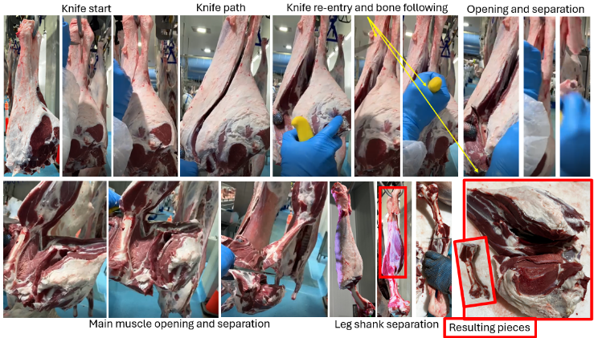

Figure 1: Steps to debone lamb legs.
Figures 2 and 3 present the steps in beef leg cutting at Plants A and C visited in Australia. The stages of separating sub-primal meat from the hindleg achieve exposure of the leg bone and in turn the full deboning of the leg.
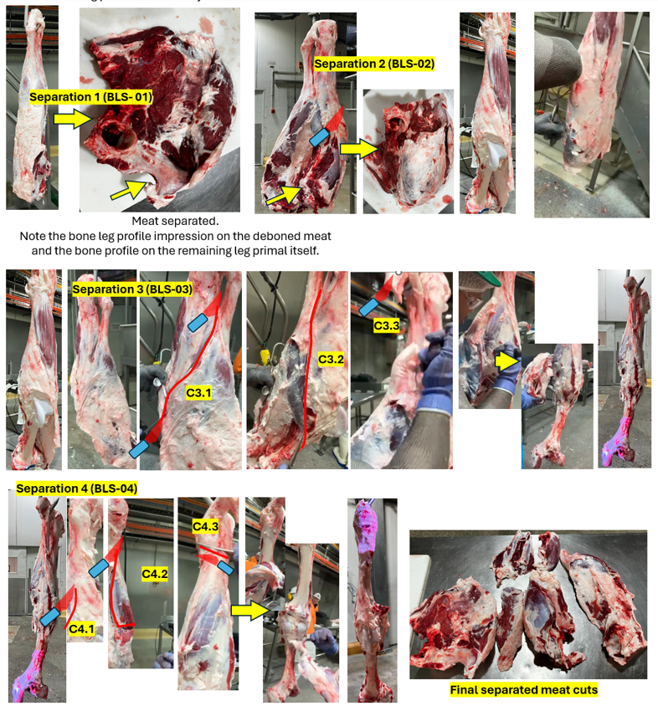
Figure 2: Steps in beef leg deboning at Plant A.
Separation steps from BLS-01 to BLS-04 (Figure 2) involve several cuts and incisions in the manual to separate meat from meat to gain visibility of bone before performing seam cutting at the bone – meat muscle boundary. Figure 3 shows a similar sequence of steps achieving the same, whilst the group of sub-primal cuts remain together, requiring separation from each other as follow up steps, once separated from the leg bone.
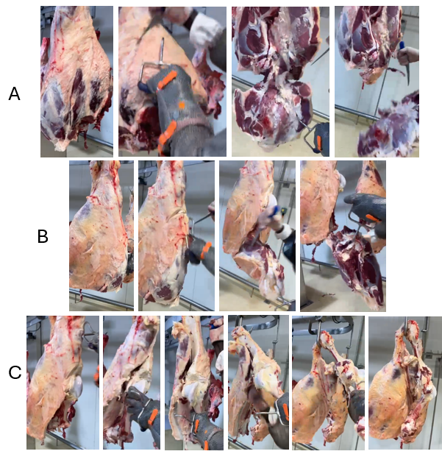
Figure 3: Steps in beef leg deboning at Plant C.
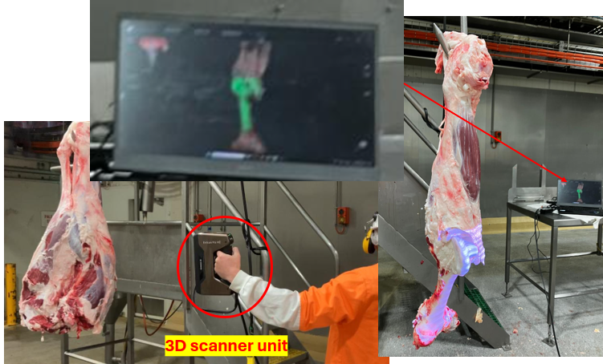
To aid the future considerations of machine development, including the adaptation of existing Mayekawa equipment, 3D scans have been made (Figure 4) of typical size lamb and beef legs facilitated by the plants visited.

Figure 4: Scanner used for 3D measurement and CAD profiling.
Figure 5 presents an illustration of the 3D models, where the information may be used to determine cut path profile for specific separation steps important to the specification of the equipment and design features including sizing of robots and type of solutions for handling or fixation.
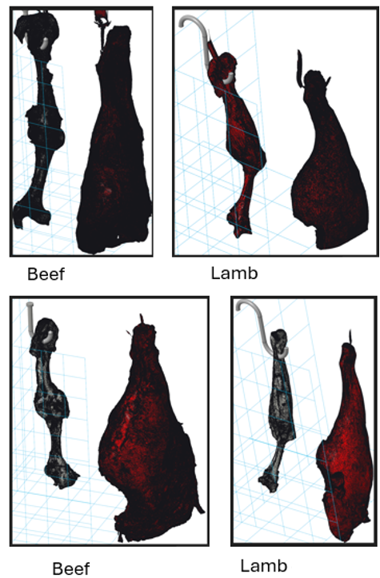

Figure 5: Typical 3D model of beef and lamb as sub-primal meat cuts.
Stage 2: Lamb Leg Trials using Existing TAKIDAS Unit
Trials using Mayekawa’s TAKIDAS (commercial unit designed for turkey leg deboning) were carried out with lamb hind legs to identify the current performance of a pre-existing commercial technology.
- Six legs were processed in initial trials, identifying critical adaptations (ankle/hock clamping, scraper design, knee joint sensing).
- A second trial incorporated prototype modules of meat separation stations considering pressure increased and modified pulling modules.
Key outcomes that were observed through this stage were:
- Consistent separation achieved using TAKIDAS unit at most stations after modifications.
- Estimated throughput capacity: 400 legs/hour using two LALDAS units (one for left legs and another for right legs).
- TAKIDAS is a standard Mayekawa product trialled with lamb hind legs.
Figure 6 shows the stages each lamb leg progressed though standard TAKIDAS in the trials, highlighting the elements or the settings that work to satisfaction and those features that need to be adjusted or redefined in design or configuration.
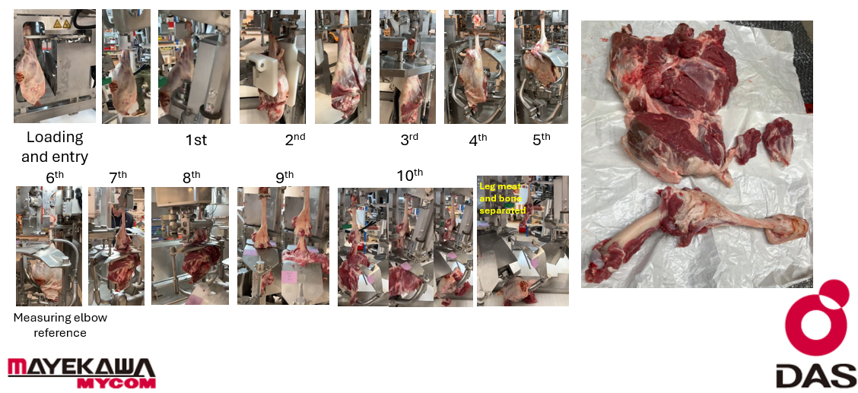
Figure 6: TAKIDAS stages of cutting, separation in lamb leg deboning.
Stage 3: Sensing Evaluation and Requirement Definition
Analysis of lamb and beef legs identified the following:
- Lamb: Whole-leg deboning achievable without additional sensing though it is recommended that additional sensing / imaging (X-ray/vision) be investigated, in a future project, for the option of providing a bone-in-hind-shank.
- Beef: Sensing is essential for cut trajectory definition due to anatomical complexity. HAMDAS/CELLDAS X-ray methods used for pork may provide a reference, but further research is required for this adaptation to be translated for beef.
The key result of this stage was ascertaining that beef leg deboning requires further R&D development of sensing techniques, while lamb leg deboning can progress directly without additional sensing development.
Stage 4: Mapping of Beef Leg Deboning Process
Manual deboning at Plant C was mapped against current Mayekawa technologies’ (HAMDAS/CELLDAS) cutting schemes. This study identified:
- The cutting methods of Mayekawa’s CELLDAS and HAMDAS provide a practical approach for developing beef butt deboning though further R&D is required.
- First feasibility tests with CELLDAS recognition unit showed limited X-ray recognition, confirming the need for developing a validated sensing methods tailored to beef as a priority.
A future BELDAS machine is feasible, designed as a scaled-up vertical CELLDAS with femur bone fixation and robotic manipulation.
The mapping of HAMDAS and CELLDAS cuts, reveal several important and necessary next steps that may be undertaken under a parallel study. These include:

- Assessment of sensing methods as in HAMDAS and CELLDAS with the modification of CELLDAS as may be practical for use with Beef butt.
- Trials to perform practica separation to assess and define the degrees of freedom, attachment positions, angles of approach, manipulation range, cutting forces, knife blade specification, and many other parameters that would help the specification of a BELDAS.
- Practical cutting as test practices for robotic to validate and determine sensing requirements for each robotic cutting, fixation and manipulation action.

Stage 5: Value Proposition Analysis
It was identified that automated deboning would assist to improved worker health avoiding repetitive strain, increase food safety, reduce cost of operation (including labour, recruitment and associated overhead costs), minimise waste and optimise yield. This stage quantified the economical benefits for both lamb and beef leg deboning.
RSI compensation carries insurance cost as well as unpredictable claim frequency that could cost an average of A$100k per claim.
Repetitive Strain Injury Compensation: Withstand Lawyers as Figure 7.
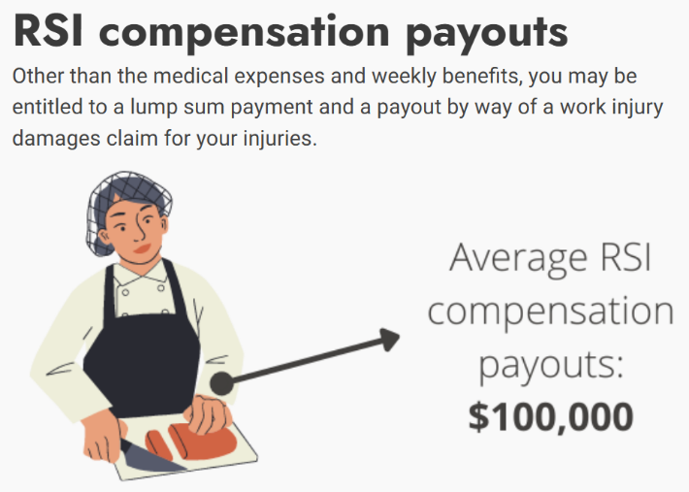
Figure7: RSI related value proposition.
A potential avoidance of 2 claims per year, by plants using LALDAS or BELDAS would reduce WorkSafe premiums and contribute around A$200k to the value proposition.
The value proposition, accounting for all the benefits as presented in Table 1 suggests a relatively short ROI.
Table 1: Value proposition overview.
Stage 6: Industry Engagement
Industry engagement has been sought throughout the project to ensure that R&D developments are focused on Processors’ needs.
- More than 20 processors were engaged
- Presentations were made to Processor during IFFA 2025 (Germany) and the AMPC Showcase (Brisbane).
- Feedback confirmed strong demand for automation, with processors estimating potential adoption.

Discussion
The results of this project clearly demonstrate that automation of lamb and beef leg deboning is both technically feasible and highly valuable for the red meat industry. Importantly, the work progressed beyond theoretical assessment to include plant benchmarking, prototype trials, and processor engagement, providing confidence that the pathway toward adoption is realistic and achievable.
Future research will examine opportunities for integration of X-ray and AI, particularly in refining cut trajectories, improving adaptability to carcass variability, and enabling self-improving automated systems. Close collaboration with processors will remain to ensure designs reflect operational realities and deliver genuine value.

Conclusions
This project has performed a scoping study for automation of lamb and beef leg deboning, applying also practical evaluations to substantiate the validity of options considered realistic for implementation, justifying future R&D. The work has reached highly valuable first results for the Australian red meat industry. Through plant benchmarking, experimental trials, process mapping, and processor engagement, the project conclusions provide a clear pathway for future development of robotic solutions that will address longstanding in labour, yield, and worker safety challenges.
Lamb automation may progress to prototype demonstration and industry trials, while beef automation should form the focus of a subsequent targeted research program being defined.

Bibliography
Aly, B., et al. (2023) ‘Robotics and sensing technologies in red meat processing: A review’, Journal of Food Engineering, 351, p. 111542. Available at: https://www.sciencedirect.com/science/article/pii/S0924224423001590
Bogue, R. (2009) ‘The role of robots in the food industry: a review’, Industrial Robot: An International Journal, 36(6), pp. 531–536. Available at: https://www.researchgate.net/publication/241700510_The_role_of_robots_in_the_food_industry_A_reviw
Frontiers (2025) ‘A review of robotic and automated systems in meat processing’, Frontiers in Robotics and AI, 2 February. Available at: https://www.frontiersin.org/journals/robotics-and-ai/articles/10.3389/frobt.2025.1578318/full
Esper, I., et al. (2020) ‘Robotisation and intelligent systems in abattoirs’, Journal of Food Engineering, 276, p. 109858. Available at: https://www.sciencedirect.com/science/article/pii/S0924224420306798
Safe Work Australia (2019) Work-related musculoskeletal disorders in Australia 2019. Available at: https://www.safeworkaustralia.gov.au/resources-and-publications/reports/work-related-musculoskeletal-disorders-australia-2019
Science Forecast (2018) ‘Prevalence of musculoskeletal disorders among slaughterhouse workers’, Journal of Preventive Research in Musculoskeletal Function, 2(1), pp. 10–15. Available at: https://www.scienceforecastoa.com/Articles/JPRMF-V2-E1-1010.pdf

Acknowledgements
Mayekawa and the project team would like to thank the AMPC and the meat processors in Australia for kind and important contribution to this work.

