EXPRESSION OF INTEREST (EOI)
EOI Reference | 2026-1004-EOI112 | EOI Close Date | 22/9/2025

Project Code | 2026-1004 | Research Organisation | integratedSTEM Pty Ltd
Project Title | The Future of MeatTech’ Professional Processing Careers 2026

Project Summary
Meat Tech STEM Camps – Shaping the Future Workforce
AMPC is inviting processors to take part in the Meat Tech STEM Camps – a flagship program inspiring the next generation of tech-skilled talent. These camps give Year 10–12 students an immersive, hands-on experience with robotics, electronics, and automation, showcasing the sophistication and innovation of modern red meat processing.
By getting involved, processors can showcase their facilities as technology-driven workplaces, attract bright young minds into the industry, and help shift community perceptions towards opportunity, growth, and innovation.
Here is a link to a promotional video: https://www.youtube.com/watch?v=fhe6KRgxiMc

Type of Industry Participation Required
Workshop

Detailed Requirements for Participation
Below is an example of the two day workshop timetable:
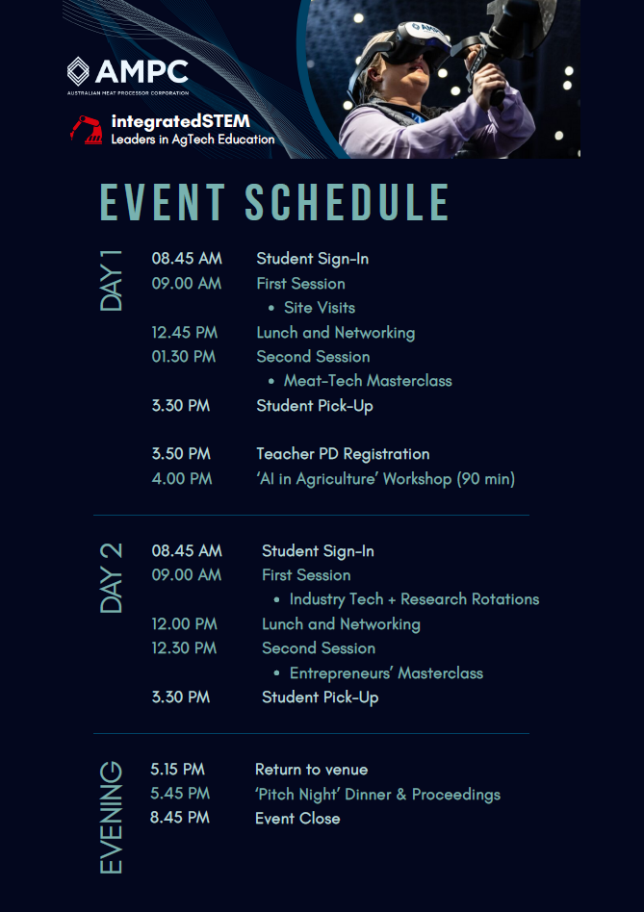

Benefits of Participating
Showcase Innovation – Showcase your plant and the industry as a leader in technology and innovation.
Attract future talent – Inspire tech-minded students to consider a career in red meat processing.
Shift perceptions – Demonstrate the sophistication and career opportunities within the industry, changing how young people and their parents view processing.
Engage with teachers and inspire them to help promote the industry via the curriculum.
Support industry growth – Help address the skills gap by encouraging the next generation of engineers, technicians, and innovators.

AMPC Contact Details
Program Manager: Amanda Carter
Email Address: A.Carter@ampc.com.au
Phone Number: 0429 658 124

EOI RESPONSE FORM
If you are interested in participating in the work being undertaken as part of project 2026-1004 The Future of MeatTech’ Professional Processing Careers 2026, please complete this form and return it to eoi@ampc.com.au no later than COB 22/9/2025.
EOI Reference | 2026-1004-EOI112

Member Details

Processing Company
Participating Plant/s*
*If the Processing Company has multiple sites, please note which plant/s will be participating in the project
Contact Person

First Name |  | Surname
Position
Phone Number |  | Mobile Number
Email Address

Participation Type

Please select the activities you are interested in participating in:
Workshop

Important Note
Members are responsible for assessing individual Projects, including the risks, benefits and terms of engagement with the relevant Research Organisation proposed to undertake the Project. By completing and submitting this EOI Response Form, or subsequently agreeing to participate in the Project to which this EOI Response Form relates, the member agrees that AMPC accepts no responsibility or liability to the member or any of the member's employees, contractors, representatives and agents in connection with the EOI Response Form or any Project to which the EOI Response Form relates, and the member releases AMPC from any loss, damage, cost or expense incurred in connection with the member's submission of this EOI Response Form or its participation in any Project to which this EOI Response Form relates.
The member is responsible for negotiating the terms of any interaction between it and the Research Organisation regarding the Project, including access to premises, safety procedures, and being responsible for obtaining and maintaining adequate insurances.
Signature of Authorised Member Representative
Full Name
Position
Date
erh
bwrb

