AMPA3015 Perform animal slaughter in accordance with Halal certification requirements
Training and assessment support materials

Australian Meat Processing Training Package
Certificate III in Meat Processing

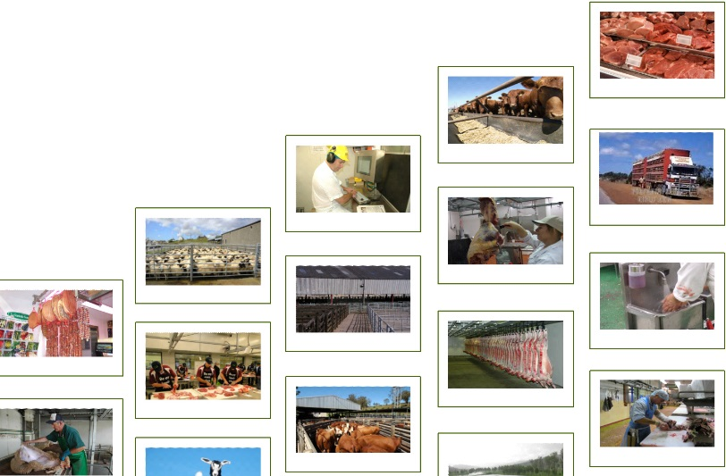

© National Meat Industry Training Advisory Council (MINTRAC) 2022

All rights reserved.

This work contains extracts of materials that were produced initially with the assistance of funding provided by the Commonwealth Government through the Australian National Training Authority (ANTA) in 2001.

These materials were created in 2022 with the assistance of funding provided by the Australian Meat Processor Corporation (AMPC).

This work is copyright, but permission is given to trainers and teachers employed by Australian Registered Training Organisations, meat industry employers and Authorised Islamic organisations to make copies for use within their own training organisation or in a workplace where the training is being conducted. This permission does not extend to the making of copies for use outside the immediate training environment for which they are made, nor the making of copies for hire or resale to third parties. For permission outside of these guidelines, apply in writing to MINTRAC.

First published 2022

Published by National Meat Industry Training Advisory Council Ltd
Suite 7, 2-4 Northumberland Drive
Caringbah NSW 2229
Telephone +61 2 9819 6699
Facsimile +61 2 9819 6099
Web Site: mintrac.com.au

Disclaimer
This training material has been prepared with the assistance of industry sources and by reference to current legislation. However MINTRAC accepts no responsibility for any consequence of oversight, misinterpretation or error in the material.

The material does not purport to be a substitute for your own legal obligations and MINTRAC recommends that it be used only as a guide to training.

Currency of training can be achieved by using proper enterprise work instructions and standard operating procedures combined with appropriate reference to current local, state and federal legislation.
Table of contents
Note to users 5
Companion Volume 5
Please help to keep these materials current 5
Using these support materials 6
What are the materials for? 6
How can they be used? 6
How are the materials organised? 6
Additional resources 7
Customising the MINTRAC Training and Assessment materials 7
Adding company-specific information 8
Incorporating changes to legislation and regulations 8
1. Training support materials 8
2. Suggested activities 9
3. Sample assessment tools 10
Australian Core Skills Framework information 13
What is the Australian Core Skills Framework? 13
Skills checks for the meat processing qualifications 14
Training support materials for AMPA3015 Perform animal slaughter in accordance with Halal certification requirements 15
Requirements for Halal certified meat 15
What are the rules and conditions required for Halal slaughter? 15
What are the specific importing country standards and requirements? 16
What are the specific customer requirements for Halal products? 16
What are differences between Halal and non-Halal stunning and slaughter procedures? 16
What regulations and standards relate to the Halal slaughter of animals? 16
What are the enterprise personal hygiene requirements to prepare for work? 18
Restraining animals 18
Why are animals restrained? 18
What equipment is used to restrain animals? 19
Halal compliant stunning 22
What is Halal compliant stunning? 22
Percussive Stunners 23
What are percussive stunners? 23
How does stunning with a percussive mushroom head work? 24
How is a percussive stunner operated? 25
How do you achieve an effective stun? 25
What are the signs of an effective percussive stun? 26
What is the stun/stick interval? 27
How and when are Halal skull checks performed? 27
How are non- Halal carcases labelled and segregated from Halal product? 28
Electrical Stunners 28
What are electric stunners? 28
How does electric stunning work? 29
How do you achieve an effective stun? 29
What are the signs of an effective electrical stun? 30
What if the stun is not effective? 31
How do I know that the stunning is not causing unnecessary suffering to animals? 32
How should electrical stunning equipment be maintained? 32
What should you do if contamination occurs during stunning? 33
The Halal slaughtering process 33
Who can perform Halal slaughter? 33
Where can animals be Halal slaughtered? 34
Why are animals bled at slaughter? 34
How are animals bled in Halal slaughter? 34
Why is a quick, spontaneous and complete bleed important? 37
How are Halal and non- Halal carcases identified and recorded? 37
How is equipment prepared for use and stored? 38
What are the main WHS risks you might need to consider when bleeding animals? 38
How can WHS risks be reduced? 39
What are the hygiene and sanitation requirements when bleeding? 40
What are the possible sources of contamination? 41
How can these sources of contamination be avoided? 41
Bibliography 43
Assessment materials for AMPA3015 Perform animal slaughter in accordance with Halal certification requirements 44
Selecting and briefing Workplace Referees 44
What to consider when using a Workplace Referee 45
Recording assessment information 46
Notations 46
Photos 46
Recordings 46
Addressing the Language, Literacy and Numeracy (LLN) requirements of this unit 47
Reasonable adjustment 47
The MINTRAC sample assessment tools 47
Key assessment requirements for this Unit of Competency 47
Are the MINTRAC sample assessment tools ‘validated’? 48
How to use the sample assessment tools 48
The Evidence Guide 49
Evidence guides 49
AMPA3015 Perform animal slaughter in accordance with Halal certification requirements 49
Workplace referee's report 53
AMPA3015 Perform animal slaughter in accordance with Halal certification requirements 53
On-the-job demonstration with assessor observation 57
AMPA3015 Perform animal slaughter in accordance with Halal certification requirements 57
Test or quiz 61
AMPA3015 Perform animal slaughter in accordance with Halal certification requirements 61
Answer sheet (for assessor use only) 64
Record of completed assessment 68
AMPA3000 Stun animal 68

Note to users
These training and assessment support materials must be read in conjunction with the Australian Meat Processing Training Package, as described on www.training.gov.au.
In particular, trainers and assessors must address the requirements described in:
- the complete training package, as presented on www.training.gov.au
- the complete Unit of Competency, as presented on www.training.gov.au.
Companion Volume
A Companion Volume has been developed to assist trainers with the delivery and assessment of training in the meat processing industry. The Companion Volume is available as a pdf document from MINTRAC.
Please help to keep these materials current
MINTRAC intends to regularly update these materials to ensure that they continue to reflect current practices and regulatory requirements in the industry.
Please assist in this process by taking the time to notify MINTRAC of any errors, changed requirements, incorrect information, additional materials, or any other ways in which these materials might be improved, by emailing mintrac@mintrac.com.au.

Using these support materials
What are the materials for?
The materials are for the Australian Meat Processing Training Package.
How can they be used?
The support materials can be used by trainers to:
- plan and deliver training
- give additional information to trainees
- keep a record of the training they have delivered.
The support materials can be used by assessors to:
- plan assessment – after training and for recognition of current competence/prior learning
- show trainees the areas they need to work on to be competent
- keep a record of the evidence used in assessment.
An assessor from an RTO must utilise the religious expertise of the Approved Islamic Organisation (AIO) when assessing of the Halal slaughter person’s compliance with the AIO’s Approved Arrangement and importing country requirements.

An RTO 's trainer should work with the Approved Islamic Organisation’s personnel when customising the training and assessment materials and delivering the training to trainees who meet the employment requirements of the relevant AIO.

Some parts of these training materials can be used by trainees:
- as a resource during training
- to review knowledge, understanding and learning
- to prepare for assessment.
How are the materials organised?
Each booklet covers one unit of competence from the Training Package. The unit title identifies which unit the materials support.
The Training Support materials provide an overview of the subject/process and the underpinning knowledge applicable to the Unit. Topic headings are used to break the training material into sections.
The questions and answers cover the required knowledge that trainees need to know for the particular unit. Trainers need to understand this information before the training starts. Assessors also need to understand this material before they assess anyone for this unit.
Green boxes with suggested activities include on and off-the-floor activities that trainers can use to help the trainees understand the information.
Trainers can also develop their own ideas for training, to suit the trainees.
The Training record sheet is for trainers to keep a record of the training activities they have completed.
The Assessment section provides general information on how to approach and prepare for Assessment. It is important that this section should be read in conjunction with the advice provided in the Companion Volume.
The Evidence Guide maps the Elements and Performance Criteria to the sample Assessment Materials provided for this unit. It is important to note that assessors may need to modify the Evidence Guide after they have customised the materials to suit each individual assessment situation.
The Assessment Materials are sample materials which can be customised and used to assess the requirements of this Unit of Competency. Assessors can also develop their own Assessment Materials to suit the trainees.
The Bibliography lists the books and other sources of information that were used to write the training materials.
Additional resources
Please refer to the Companion Volume for generic resources and references in relation to Training and Assessment.
A range of industry-produced materials plus resources developed by other organisations may be available to support this Unit. For an updated list of available resources, please refer to the Unit-By-Unit listing of resources on the MINTRAC website at www.mintrac.com.au
Customising the MINTRAC Training and Assessment materials
The entire document of Training and Assessment materials for a Unit of Competency is a trainer resource and should never be reproduced and handed to trainees without customisation.
Below are some important guidelines to assist with customisation.
Adding company-specific information
Every meat processing company is different. The training and assessment should match the operations of the company and the requirements of the units of competence. The material in this booklet must be customised to the company's and trainee's needs by including the:
WI | Company work instructions for the tasks in the material.
SOPs | Company standard operating procedures for the tasks in the material.
E | Company equipment used for the tasks in the material.

AA | Relevant parts of an Approved Islamic Organisation’s Approved Arrangement.
Incorporating changes to legislation and regulations
These training materials must be updated for any changes in relevant legislation, regulations, guidelines and codes of practice – for example, the AS 4696:2007 Australian Standard for the hygienic production and transportation of meat and meat products for human consumption.
1. Training support materials
The information contained in the training materials is essentially a resource for trainers. Usually, the material is not suitable for reproduction and handing out to trainees without modification.
However, segments can be used with trainees, in the following ways.
- Develop short handouts or information sheets.
- Insert your own company photos.
- Insert information from your own company SOPs or Work Instructions.
- Create PowerPoint presentations using the headings, adding photographs and then use the general text to speak to the PPT presentation.
- Create one-page revision sheets with essential information.
- Add your company letterhead to the materials.
- Remove non-essential information not relevant to your company (but take care to ensure that the unit requirements are still met – check the Unit of Competency).
- Add in useful materials you have accessed from other sources.
- Modify the text and make it electronically available to students to use as reference material.
- Adjust the language and style of the text to suit your trainees' reading skills.
- Develop a short photographic or video sequence demonstrating the process/product/skill as used in your company.
- Use the materials only as a quick reference for yourself, to ensure that you have provided accurate, complete information during training sessions and on-the-job instruction.
- Update any legislation or regulations which may have changed.
- Add materials which may be needed to support language, literature and numeracy skills of trainees.
- Translate segments of the materials into the trainee's first language.
2. Suggested activities
- Create a 'task sheet' modifying the activity to suit your own company workplace.
- Add further instructions and guidelines to suit your student group.
- Modify the activity to be suitable for pairs or groups.
- Modify the activity to be completed electronically.
- Develop new activities and add to your bank of training resources.
- Add information/exercises relevant to your own Work Instructions or SOPs.
- Develop problem-solving exercises or challenges for your trainees to address using given resources.
- Add activities which help develop the language, literacy and numeracy skills of trainees, as required.
- Use a language, literacy and numeracy specialist to team teach.
3. Sample assessment tools
For the most part, three sample assessment tools are provided. If used, these will meet the requirements for three different forms of assessment. However, it is essential that they are modified before use.
Remember that whenever an assessment task is modified, it must be re-mapped in the Evidence Guide.
Modifications might include the following.
Workplace referee's report
- Remove or add questions to suit your own company SOPs and Work Instructions.
- Add your own company photographs and letterhead.
- Modify the format so that there is plenty of room for the Referee to write comments.
- Discuss the report with the referee and add comments of your own from the conversation.
- Video the trainee at work and then discuss their performance with the referee.
Explanation, question and answer of underpinning knowledge
- Remove or add questions to suit your own company SOPs and Work Instructions.
- Divide into several shorter tests.
- Add your own instructions so that trainees are clear on the assessment requirements, what is required to 'pass', and how feedback will be provided.
- Add your own company photographs and letterhead.
- Select test questions to use as a written test – with spaces provided for trainees to write their answers.
- Create sample questions sheets for trainees to test each other.
- Use the test as an oral test and record the answers electronically.
- Put the test on-line, so that students can enter their answers electronically, and then print off their completed test paper.
- Have the test translated into the trainee's first language.
- Allow the trainee to have access to reference materials to complete some parts of the test in 'open book' style.
- Change the test into more of an 'assignment' by allowing trainees a couple of days to seek answers to the questions by talking to work colleagues, supervisors, and reading reference materials.
- Explain how to complete the test to trainees from other cultures, for example explain what to do with multiple choice.
On-the-job assessment with assessor observation
Important note: Most of these sample assessment sheets have been written with the assumption that the assessor will have an opportunity to talk to the trainee during the assessment. In many situations, this will not be practical. If the assessor is not able to speak to the trainee during the assessment, the assessment task must be modified, and re-mapped to the Evidence Guide.
- Remove or add questions to suit your own company SOPs and Work Instructions.
- Video the trainee performing the task, and then at a separate time, meet with the trainee to discuss the trainee's performance and address the underpinning skills and knowledge requirements.
- If safe, ask the trainee to talk about the task as they are working; you can ask probing questions to address underpinning skills and knowledge areas.
- Make detailed notes of your observations as the trainee works, and then separately discuss your observations with the trainee, and ask questions to address underpinning skills and knowledge requirements.
- Address the underpinning skills and knowledge requirements by taking the trainee off-line but remain on the floor and discuss underpinning skills and knowledge areas with them as they observe other workers.
- Modify the assessment sheet to ensure that you have plenty of space to make notes about your observations.
- Observe the trainee several times to ensure consistency of performance; ensure you record the date, time and location of each observation.
- Use an interpreter to assist with translations during the assessment.
- Observe the trainee on more than one occasion to compensate for 'assessment nerves'.
Classroom activity
- Remove or add questions to suit your own company SOPs and Work Instructions.
- Add your own company photographs and letterhead.
- Adjust the activity to be an individual, paired or group exercise.
- Use photographic or video segments to add interest to the activity.
- Use a problem-solving approach – show an example of poor performance or product and ask the trainees to identify the issues and causes.
- Develop new activities more suited to your trainee group.
- Re-write the activity as an assignment task.
- Use an interpreter to assist with translations.
- Teach with a literacy/numeracy trainer.
- Rephrase instruction to compensate for different cultural understandings.
Create your own assessment tasks
Three is not the magic number. Your trainees might be better suited to four or five shorter assessment tasks. Look at the suggestions in the Companion Volume for additional assessment approaches which might be used for that unit. Then, write your own assessment tasks. Don't forget to re-map to the Evidence Guide.

Australian Core Skills Framework information
What is the Australian Core Skills Framework?
The Australian Core Skills Framework (ACSF) provides a detailed picture of real-life performance in five core skills:
- learning
- reading
- writing
- oral communication
- numeracy.
The ACSF describes performance in each of the core skills at five levels of performance.
It can be used in vocational training to identify:
- what level of skill a trainee has?
- what level of core skill is required to successfully perform a task in the workplace?
- what skills gaps exist between the trainee's skills and the required skills.
[Insert unit code and name]
 | Level | Example
Learning | 1 | - checks product against specification to get a match  - understands levels of contamination  - follows instructions
Reading |  | - reads and applies appropriate policies, specifications and work instructions with assistance
Writing |  | - signs work instructions
Oral |  | - communicates with trimmers and supervisors regarding defect problems and listens to and accepts feedback
Numeracy |  | - Identifies mathematical concepts, such as measurements in work instructions or specifications  - reports to trimmers on out of specification product, possibly involving numerical language  - understands levels of contamination
Level 1 assumes the trainee is working alongside an expert/mentor where prompting and advice can be provided. The tasks are highly familiar with a very limited number of steps (1 to 2 steps).
Level 2 assumes the trainee may work with an expert/mentor where support is required if necessary. The tasks are familiar and in predictable contexts.
Level 3 requires the trainee to work independently in a range of contexts including some that are unfamiliar.
Skills checks for the meat processing qualifications
This is a CD, available from MINTRAC.
This CD provides customisable language, literacy, numeracy skills check for trainees enrolling in Australian Meat Processing Training Package qualifications. The CD includes Answer Tools for trainers and recording sheets for trainee files to help identify what support will be required by the trainee. This resource was funded under the Workplace English Language and Literacy (WELL) program by the Australian Government, Department of Industry, Innovation, Climate Change, Science Research and Tertiary Education.
The skills checks should not be given to trainees as a test. Nor should they be used if the answers do not provide any advice to trainers. Do not give the skills check to the trainee just to put the results in the trainee's file.
This skills check is designed to get an indication of a trainee's language, literacy and numeracy skills on commencement of training.
Skills checks do not give an indication of whether a trainee is likely to succeed or fail in training or in their work. They are only expected to provide some advice to trainers on where the trainee might need additional support in their training in terms of language, literacy and numeracy
Training support materials for AMPA3015 Perform animal slaughter in accordance with Halal certification requirements
These materials are for training in AMPA3015 Perform animal slaughter in accordance with Halal certification requirements in the Certificate III in Meat Processing.
Requirements for Halal certified meat
What are the rules and conditions required for Halal slaughter?
Halal stunning is a stunning method accepted by an Approved Islamic Organization that is engaged to certify product as Halal. Halal stunning is considered reversible. The animal must die from the loss of blood after being slaughtered by a registered Halal slaughterman.
The Halal stunning method for goat, sheep and lambs is head only electric stunning. Halal slaughter for goats and sheep involves the use of the transverse stick. This is when the Halal slaughter person draws a sharp knife across the throat, i.e. the cut transverses the throat. This is dealt in more detail in the sections below.
The approved Halal stunning methods for cattle include electric head only stunning and percussive stunning. Halal slaughter for cattle involves the use of the transverse stick. This is when the Halal slaughter person draws a sharp knife across the throat, i.e. the cut transverses the throat. This transverse stick is followed by a thoracic stick to ensure that the beast does not regain consciousness before the animal dies of blood loss.
Each AIO documents its Halal slaughter procedures in its Approved Arrangement (AA). The AIO’s AA may be based on any of a range of Halal Standards. Examples of these standards include:
- OIC/SMIIC 37: 2022 Halal Products- Usage of Animal Bone, Skin and Hair- General Guidelines
- Malaysia Standard MS1500: 2009 Halal Food Guidelines.

What are the specific importing country standards and requirements?
To be customised AIO and RTO

What are the specific customer requirements for Halal products?
To be customised AIO and RTO
What are differences between Halal and non-Halal stunning and slaughter procedures?
Halal stunning and slaughter involves procedures that are compliant with the Islamic religious requirements for the slaughter of animals.
In Australia the export of Halal meat and meat products is certified by an Approved Islamic Association (AIO). These AIOs oversee the procedures for stunning and slaughter as well as the work of the Halal slaughterer. The Halal slaughterers and trainee slaughterers are placed on an AUS-MEAT register by an AIO.
Non-Halal product would include
- product from an animal killed by the stunning process
- product from a diseased animal
- product from an animal slaughtered by a person other than a registered Islamic slaughterer
- a non-Halal species such as pork
- product that had been in contact with non-Halal product.
These and other reasons would mean an AIO could not certify product as Halal.

What regulations and standards relate to the Halal slaughter of animals?
All abattoirs in Australia must comply with Australian Standard AS 4696:2007 Hygienic Production and Transportation of Meat and Meat Products for Human Consumption.
The objective of this Standard is to ensure that the meat produced is wholesome and fit for human consumption. The Standard sets out minimum requirements for:
- animal welfare
- hygiene
- meat inspection
- slaughtering
- boning
- packaging
- chilling and freezing
- buildings and equipment
- transport of meat.
Export meat processing establishments may have further requirements of the importing countries as well as the Export Control (Meat and Meat Product) Rules 2021.
Abattoirs producing Halal product will also have to meet the requirements of the relevant Approved Islamic Organisation that will certify the Establishment’s product as Halal.
In addition, there are a range of specific regulations or requirements in relation to the restraint, stunning and sticking operations that are applicable to Halal slaughter.
The Australian Standard AS 4696 :2007 for the hygienic production and transportation of meat and meat products for human consumption states the minimum standards that must be met for the handling and slaughtering of animals at abattoirs. Specifically, the standard requires:
7.9 Animals are slaughtered in a way that prevents unnecessary injury, pain and suffering to them and causes them the least practicable disturbance.
7.10 Before sticking commences animals are stunned in a way that ensures that the animals are unconscious and insensible to pain before sticking occurs and do not regain consciousness or sensibility before dying.
7.11 Before stunning commences animals are restrained in a way that ensures that stunning is effective.
In addition, the Australian meat industry has developed the AMIC Industry Animal Welfare Standard for Livestock Processing Establishments Preparing Meat for Human Consumption (Edition 3). This voluntary Standard captures both the legal requirements and best practice animal welfare procedures for meat processing plants in Australia. The requirements of this Standard are incorporated into the Approved Arrangements (QA programs) of the participating abattoirs.
Export meat processing establishments must comply with the Export Control (Meat and Meat Product) Rules 2021. And depending on the markets the company services, other regulations that may have to be met include specific importing country requirements.
The requirements of the relevant legislation and Standards from the list above will have been included in the workplace's procedures.
There are three factors involved in humane slaughter:
- animal factors
- facilities and equipment factors
- human factors.
All of these factors are taken into account when developing standard operating procedures and work instructions for the slaughter process. That is, the facilities should be designed to complement normal animal behaviour, reduce stress and assist properly trained personnel to do their job easily and efficiently.
What are the enterprise personal hygiene requirements to prepare for work?
Each company has hygiene requirements which are documented in the Approved Arrangement. They include Standard Operating Procedures for personal hygiene that include
- lockers
- clothing
- eating and smoking
- boot washing and hand washing
- equipment and knife kit sterilising and cleaning.

Stunning and slaughter are covered by work instructions, and these describe the specific requirements for each task.

Restraining animals
WI | Why are animals restrained?

Animals are restrained prior to stunning to ensure that:
- an effective and humane stun can be achieved
- product quality is maintained
- relevant state and national regulations and workplace procedures are met
- the risk of injury to workers will be reduced.
The relevant regulations should be included in workplace procedures for each individual site. AS4696 requires that:
7.11 Before stunning commences animals are restrained in a way that ensures that stunning is effective.

E | What equipment is used to restrain animals?

A range of equipment is used to restrain animals prior to stunning. The type of equipment used at each site will depend on the scale of the operation, and the species and type of stock being processed.
Types of restraining equipment currently used in the industry include:
- knocking or stunning box
- v-belt conveyors
- head restrainers and positioners
- catching pens
- double rail restrainers.
Knocking or stunning box
This is a box usually constructed from steel or concrete and designed to hold one animal comfortably for the stunning process to be performed. The size of the box will depend on the type and size of stock (vealers, bulls) or species (sheep, goats) being processed. These boxes are usually fitted with mechanically operated sides and/or floors which open to release the animal after it has been stunned.
The knocking box is fed by a narrow race leading from the holding pens.
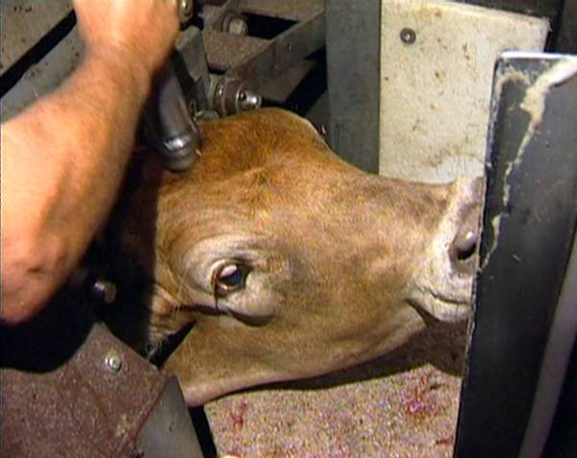
Knocking box
© Des Bowler
V-belt conveyors
V-belt conveyors are mechanical devices fed by a narrow race from the holding pens. They consist of two parallel conveyors which are wider on the top. The conveyor belts are usually constructed from timber or plastic slats on rubber belting. Because they have no floor, the animals are automatically restrained when they enter the conveyor. They are then conveyed to the point for stunning.
The size of the conveyor will depend on the type or species of stock being processed, e.g. cattle, sheep, goats. Conveyors can be used for most species of stock.
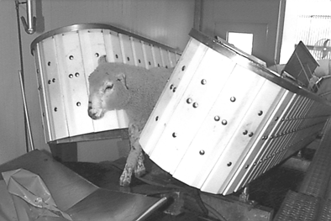
V-belt conveyor for mutton - front view
© Wodonga Institute of TAFE

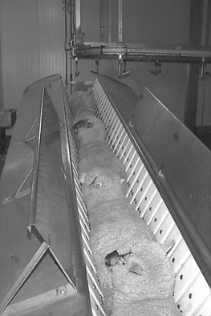
V-belt conveyor for mutton - view from above
© Wodonga Institute of TAFE

Head restrainer
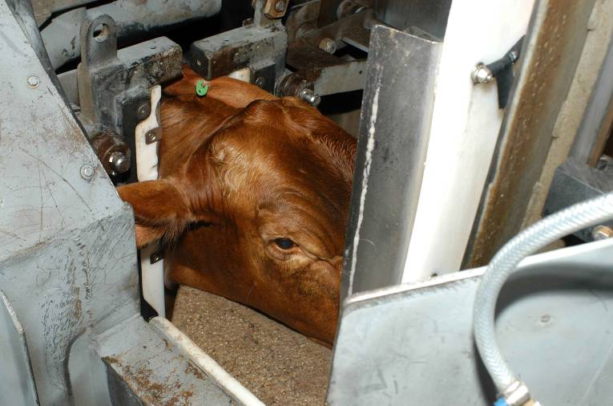
Head restrainer unit
© MINTRAC
Head restrainer/positioning units are normally only used on large stock such as cattle. Their use is usually confined to plants that process significant numbers of cattle from large holdings or stations. In northern Australia these cattle are often easily excitable due to their previous lack of contact with people, and therefore require a more specialised restraint process.
There are three types of devices commonly in use:
- the ‘fixed’ shelf or head positioning device
- the cantilever yoke system with two vertical moving bars
- the head yoke and chin lift system which holds the head fast.
These systems improve stunning placement accuracy, but if poorly designed and poorly used, can result in increased stress to the animal.
Head restraint is an important prerequisite for ritual slaughter of large stock.
Catching pens
Catching pens are usually found in small scale operations that don't need a conveyor or knocking box.
They are only used for small stock such as sheep, goats and calves. Catching pens should be small enough to ensure the animals are sufficiently restrained and can be easily stunned prior to sticking.
They should only be permitted for use when the relevant stun/stick interval for the species is always achieved.
Double rail restrainers also known as brisket, belly or central conveyors
Double rail restrainers are mechanised restrainers and conveyors. They differ from the V-belt conveyor in two ways. They have vertical sides and not angled sides, and the conveyor mechanism is a central double rail conveyor.
When the animals enter the conveyor on a non-slip sloping ramp, they are suspended in a straddle position on the rail conveyor. Their belly and brisket rest on the moving conveyor.
Double rail restrainers can be used for cattle and sheep; the type and species will determine the size of the system. Double rail restrainers designed for each species can be adjusted to suit different types of stock, e.g. vealers or cows.
Halal compliant stunning
What is Halal compliant stunning?
Halal compliant stunning should result in making the animal unconscious and insensible but must not kill the animal. Death must be caused by the bleeding process.
When an animal is stunned, it is rendered unconscious and insensible to the pain of the slaughter process. This is to ensure that the risk of pain inflicted on animals is minimised, and the requirements of AS4696, the Australian Standard, Industry Animal Welfare Standards – livestock processing establishments preparing meat for human consumption (third edition), Codes of Practice and relevant legislation are met.
Stunning animals reduces the risk of injury to workers. Stunning also minimises stress on animals at the point of slaughter. This aids in maximising meat quality. The stunning of animals prior to slaughter is normally a mandatory requirement.

What stunning equipment can be used for Halal slaughter?
A range of equipment can be used to stun animals. The type of equipment used at each site will depend on the type and size of stock or species being processed.
It is important that the correct workplace procedures for using the stunning equipment at your site are followed.
There are two main types of equipment used for stunning for Halal slaughter:
- percussive stunners (mushroom – reversible)
- electric stunners
Percussive Stunners
What are percussive stunners?
Percussive stunners fire a mushroom shaped head out of the barrel of the ‘gun’. The different types of percussive stunners are powered by either blank cartridge or compressed air. It should be noted that percussive stunners powered by cartridges are banned by some importing countries.
Cartridges come with varying power loads for different types of stock and are classified according to the amount of explosive material they contain. The amount of charge usually varies between 6.0gr for large stock and 2.5gr for small stock. The most commonly used calibre is 0.22 calibre, but 0.25 calibre equipment is also used in some plants.
Compressed air powered percussive (pneumatic) stunners are most commonly used for Halal slaughter. They run on a range of air pressures typically ranging from 7 bar (100PSI) for calves to 14 bar (203PSI) for bulls. This is only an indicator of the usual ranges and the manufacturer's instructions should be followed at all times.
Percussive stunners are activated by a trigger or by contact with the animal’s head. Contact-fired stunners are only suitable for animals restrained in a knocking box.
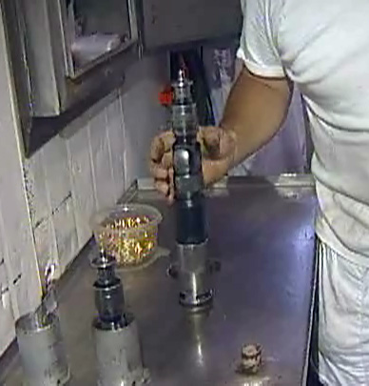
Percussive stunner
© Des Bowler
Percussive stunning
These stunners have a wide blunt end on the bolt. They are often referred to as 'mushroom head' stunners. The velocity of the impact is transferred to the animal's brain causing unconsciousness. The mushroom head only protrudes a small amount from the collar of the gun, as they are designed to stun rather than penetrate. Mushroom head stunners are required for Muslim slaughter because they do less damage to the skull bones and brain prior to the ritual sticking process. Stunning with this type of gun is considered reversible. Therefore, animals must be promptly stuck and bled after this kind of stun to eliminate the possibility of the animal regaining sensibility.
Penetrating stunners
There are stunners that can be used to kill an animal. When fired, a captive bolt penetrates the skull and enters the brain, causing unconsciousness and death. This type of stunning cannot be used for Halal slaughter.

How does stunning with a percussive mushroom head work?
The primary objective of percussive stunning in Halal slaughter is to induce unconsciousness by administering a strong blow to the head. The animal must then stay unconscious until it is bled.
The main effect of stunning with a percussive stunner is to produce a rapid movement of the head, causing the brain to collide against the inside of the skull. This causes a sudden disruption to normal brain activity and a drop in blood pressure in the brain. There is also damage to the nerves and blood vessels.
How is a percussive stunner operated?
Effective percussive stunning depends on five factors:
- accurate positioning of the equipment
- well trained operators
- use of the correct strength of cartridge/air pressure
- the velocity of the percussive head
- proper maintenance and daily cleaning of the equipment.
The main cause of improper percussive stunning is incorrect positioning of the equipment. This is often due to the animal moving its head at the last moment so that the percussive stunner is not in the correct spot when fired. To overcome this problem, operatives must be adequately trained, and the knocking box must be constructed to:
- prevent substantial movement of the animal forward, backwards and sideways
- restrict movement of the animal's head
- allow release of the head as soon as it has been stunned
- allow unimpeded access to the forehead of the animal by the person doing the stunning.
The use of the correct strength of cartridge is vital for proper stunning and the manufacturer’s specific instructions should be followed at all times.
The explosive materials used in the cartridge powered percussive stunners will cause residues that reduce the performance of the device and will, if not regularly removed, result in failed stuns and excessive wear of the equipment. So, daily cleaning of the equipment is vital for proper use.
Pneumatic powered stunners also have maintenance schedule that must be strictly adhered to.
If all these elements are addressed, stunning should be routinely effective.
WI | How do you achieve an effective stun?
The stunning operations at each site will be governed by the site workplace procedures. These workplace procedures and policies will depend on the species and category of stock being processed.
To achieve an effective stun, workers need to have an understanding of the stunning process and be trained in the correct use of the stunning equipment.
Beef
After being loaded into a knocking box or restrainer, cattle are stunned by applying the appropriate percussive stunner to the head in what is known as the ‘frontal position’ which is the yellow spot on the photo below. This position is determined by the point where two imaginary lines, drawn from the eyes to the base of the opposite horns or poll, cross over and meet at the red spot. When using a percussive stunner, it should be positioned slightly above (about 2cm) where the two lines meet on the yellow spot.
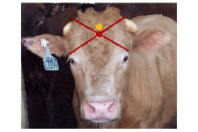
Position for a percussive stunner (yellow dot)
© L. Hewitt

WI | What are the signs of an effective percussive stun?
The AMIC Industry Animal Welfare Standard for Livestock Processing Establishments Preparing Meat for Human Consumption (Third Edition) has an implementation guide and this sets out the following as signs of an effective percussive stun:
- Immediately after stunning the animal should collapse and uncoordinated kicking may follow
- No rhythmic breathing
- No reaction to a painful stimulus
- Hangs straight down when shackled with no righting action
- No spontaneous blinking, eyes open, blank stare, no response to touch
- Nystagmus (vibrating eye) is absent.
Most abattoirs have a formal monitoring program of the stunning operation on the basis of:
- ‘Corneal reflex’– straight after stunning and at sticking
- while shackled – absence of righting reflex
- absence of rhythmic breathing
- rate of stunning to be at a level that maintains chain speed but does not allow excessive build-up of bodies in the stun/stick area
- accuracy of stun by examination of skulls for correct placement of bolt
- number of animals requiring re-stunning
- stun/stick interval meeting regulatory requirements.
What is the stun/stick interval?
This is the time it takes to stick or bleed an animal after it has been stunned. For reversible stunning the following stun to stick periods should not be exceeded.
Stunning method | Maximum delay for bleeding to be started
Head-only electrical stun | Calves | 10 seconds
 | Sheep | 10 seconds
 | Cattle | 10 seconds
 | Lamb | 15 seconds

Percussive stun) | 20 seconds in all species
After a reversible stun all animals should be bled by cutting both carotid arteries, the jugular veins, trachea and weasand (oesophagus) for Halal slaughter. AS4696 sets out the legal requirement and that is:
7.10 Before sticking commences animals are stunned in a way that ensures that the animals are unconscious and insensible to pain before sticking occurs and do not regain consciousness or sensibility before dying.
The stun/stick interval and the potential to regain consciousness before dying is also monitored as part of a company’s QA program.
How and when are Halal skull checks performed?
To be customised for each Halal Certifier and plant

How are non- Halal carcases labelled and segregated from Halal product?
Product (carcase and viscera) may be non-Halal for a number of reasons including
- product from an animal killed by the stunning process
- product from a diseased animal
- product from an animal slaughtered by a person other than a registered Islamic slaughterer
- a non-Halal species such as pork
- product that had been in contact with non-Halal product.

Halal slaughterers must identify, record and report any carcase and offal that do not meet Halal requirements, and confirm that it is segregated from Halal carcases and offal.
In addition, Halal slaughterers are also responsible for completing post-slaughter documents within organisational timeframes ensuring equipment is stored to avoid cross-contamination according to Halal requirements.
Electrical Stunners
What are electric stunners?
During electrical stunning an alternating current is passed through the animal's brain, causing loss of consciousness.
Head only
With head only stunning, one electrode is placed either side of the head in order to span the brain. This type of stun causes the animal to lose consciousness and is reversible. This method of stunning is the only type of electrical stunning acceptable when performing a Halal slaughter process because it does not stop the heart and is reversible. Halal slaughter requires animals to die from the sticking not the stunning process.
Species
Generally, sheep, goats and calves are stunned – head only – using the two pin type stunners for Halal laughter.
Electrical stunning of cattle is used in some Australian export plants. Electrical stunning of cattle is acceptable for Halal slaughter if the stunning is reversible.
How does electric stunning work?
Electric stunning induces a ‘grand mal’ or epileptic fit. This causes instantaneous unconsciousness before any pain stimulus associated with the application of the equipment can be registered on the brain. The seizure causes rigid spasms which last for at least 30 seconds.
WI | How do you achieve an effective stun?

The stunning operations at each site will be governed by the site workplace procedures. These workplace procedures and policies will depend on the species and categories of stock being processed.
To achieve an effective stun, workers need to have an understanding of the stunning process and be trained in the correct use of the stunning equipment.
Effective stunning depends on these factors:
- proper restraint of the animals
- accurate positioning of the equipment
- well trained operator
- use of the correct strength of electric current
- proper maintenance
- daily testing and cleaning of the equipment.
Sheep, lambs, goats, calves (small stock)
After being suitably restrained, small stock are stunned by applying the electric stunner to the correct position on the animal's head.

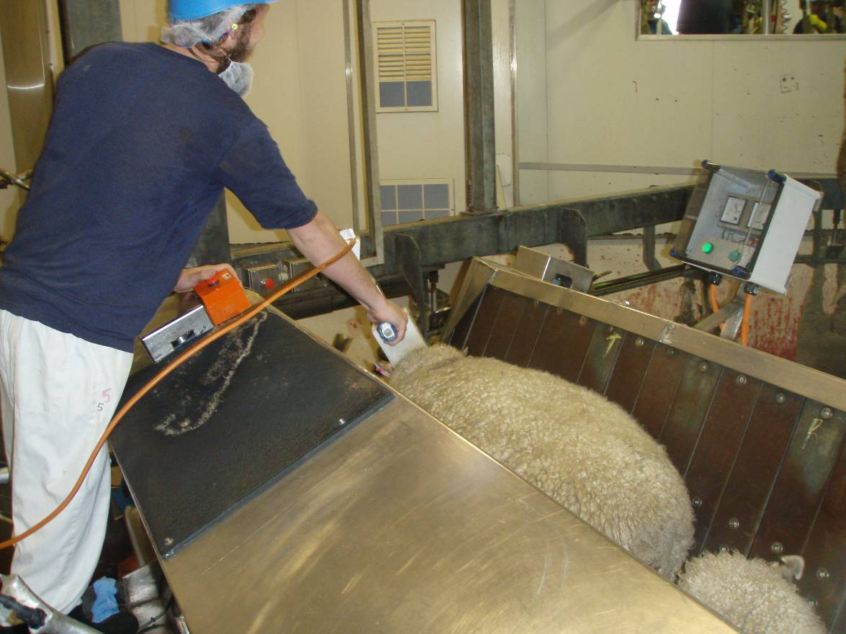
Electrical stunning of sheep
© S. Fitzgerald
The implementation guide for the AMIC Industry Animal Welfare Standard for Livestock Processing Establishments Preparing Meat for Human Consumption recommends the following amperage for electrical stunning.
Species | Minimum current levels
Cattle | 1.5A
Calves | 1.0 A
Sheep & Goats | 1.0 A
Lambs | 0.7 A

The stunning equipment should be provided with adequate power to continuously achieve the minimum current levels recommended for stunning and it is essential to follow the established workplace procedures to achieve an effective stun.

WI | What are the signs of an effective electrical stun?

There are two ways to determine whether the stunning practice is effective.
“At stun, the animal should collapse and become rigid with legs flexed immediately after the start of the current flow. Overall rigidity generally lasts for 10-20 seconds, and it is best to stick the animal when in this phase, before any kicking might occur. If the animal shows any sign of kicking or paddling movements as soon as the current is stopped, then the animal has not been effectively stunned” (Animal Welfare Standards Background Notes).
This rigid stage is called a ‘tonic stage’ and is followed by a ‘clonic stage’ where kicking and paddling movements occur, normally lasting for between 15 and 45 seconds. The presence of the tonic, followed by the clonic stage, indicates that the stun has been successful. Following these two phases, a quiet phase sets in, where the animal is quite still before the first signs of recovery will appear.
The second and equally important way to check the effectiveness of the stun is to test and monitor the efficiency of the stunning equipment. This should be done according to the relevant workplace procedure.
If the animal shows any sign of kicking or paddling movements as soon as the current is stopped, then the animal has not been effectively stunned. Equally, if the animal does not develop at least some kicking or paddling movement (clonic stage following the tonic stage) it is likely that the animal has only been paralysed rather than stunned. This is caused by the application of the stunner too far back on the neck (more than 3cm behind the line between the ears in small stock).
Eye reflexes or movements cannot be used at this stage to assess the effectiveness of the stun because eye movements are part of the epileptic fit.
What if the stun is not effective?
If the initial stun is not fully effective, then a number of actions have to be taken. These will be described in the work instructions.
The Halal sticker’s initial action will be to re-stun the animal. The supervisor should then be informed, the carcase tagged and segregated from Halal product if the follow up stun used a penetrating bolt gun.
If ineffective stunning becomes a recurring or consistent problem, then it is important to:
- report this to the supervisor
- check the voltage/charges/air pressure being used
- check the placement of the stunner
- check the routine maintenance of the stunner.
In most plants, stunning is monitored daily to ensure:
- that the animals are being stunned effectively first time
- that stunning is correctly paced with production
- that the stun/stick intervals are observed
- that excessive numbers do not build up in the stun/stick areas
- the use of incorrect voltages, cartridges, air pressure or gas levels or the incorrect placement of stunning equipment.
In the case of an equipment failure an alternative stunning device must be available for immediate re-stun.
How do I know that the stunning is not causing unnecessary suffering to animals?
There are two things you need to monitor to ensure that animals do not suffer unnecessarily:
- stunning effectiveness
- stun/stick interval.
If stunning is carried out correctly there should be no sign of sensibility in animals on the bleed rail. This may occur occasionally. Although it is the responsibility of the persons doing the stunning to ensure that all animals are insensible, it is also the responsibility of all operators working in the area to observe bodies for signs of an ineffective stun and arrange immediate re-stunning when this is observed.
Additionally, the operator responsible for sticking must, before making a cut, check for any sign of sensibility (corneal reflex) and rhythmic breathing.
If there are signs of an ineffective stun an immediate re-stunning must be arranged, and the supervisor notified. If the back-up stunner is a penetrating captive bolt, then the product must be tagged as non-Halal. This non-Halal product must be segregated from Halal product.
Animals must not be killed by the stunning process and the Halal slaughtermen must tag animals that are non-Halal and report the stunning issue to the supervisor.

WI | How should electrical stunning equipment be maintained?
Electrical stunning equipment must be cleaned regularly to ensure that a good electrical connection occurs between the stunner and the animal. The minimum cleaning schedule is once per day. It is recommended that:
- regular checks of electrical continuity and insulation should be carried out to ensure current flow to the electrodes is adequate and there is no current leakage
- electrical stunning equipment should be tested prior to use to ensure the power output is adequate to stun animals
- electrodes should be cleaned regularly to enable optimum electrical current flow to be maintained
- the equipment should incorporate a device that monitors and displays stunning current delivered to the animals. There should be a gauge, dial or light that operates during the stun and is visible in the bleeding area. These should be checked as part of the maintenance program
- the stunning equipment should be fitted with a trigger to manually initiate the stun while the current flow should be terminated automatically, and this should be checked regularly.
The effectiveness of stunners should be monitored by the Halal slaughterer throughout the operating period. Any stunners which fail during operations must not be used until after they have been repaired. Spare stunners should always be available at the point of use in case of failure.
Records should be maintained of all maintenance on stunners as part of a company's Approved Arrangement Program.
Any problems with the operation of stunners need to be reported to the appropriate person, as required in the workplace procedures.

WI | What should you do if contamination occurs during stunning?

If contamination occurs, you must take immediate action to correct the situation. The action you need to take will be included in your work instructions.
If faecal or ingesta contamination occurs at the time of stunning, it should be washed off in the dry landing area.
You must not remove contamination by scraping or wiping.

The Halal slaughtering process
Who can perform Halal slaughter?
The slaughterman must be approved by an Approved Islamic Organisation (AIO). The slaughterman must be a practicing Muslim of good character, sound mind and possess a valid Slaughterman ID issued by AUS-MEAT.
The slaughterman must work to the Approved Islamic Association’s Approved Arrangement that has been signed off by the establishment and the Commonwealth Department of Agriculture.
Where can animals be Halal slaughtered?
Halal slaughter is performed in a registered export abattoir with an AUS-MEAT Approved Arrangement that is overseen by an Approved Islamic Organisation. The slaughterhouse area must be clean and must comply with the cleanliness criteria set by the competent authority and approved by the supervising Approved Islamic Association.
Pigs cannot be slaughtered or processed at the establishment and pork cannot be stored at the abattoir.
Why are animals bled at slaughter?
Animals are bled immediately after stunning to stop the blood supply to the brain. This is necessary to make them brain dead before further dressing procedures commence.
Bleeding also allows the maximum removal of blood from the carcase. Incomplete bleeding can result in meat with a higher pH and higher moisture content. This may increase the rate of spoilage by micro-organisms.

WI | How are animals bled in Halal slaughter?

Halal slaughter requires the transverse stick of the animal’s neck.
Bleeding sheep, goats, venison
Before any cut is made, the operator must check for an effective stun. The signs of an effective stun were discussed earlier in these materials.
The sheep must be laid on its left side and positioned according to the Approved Arrangement.
The transverse stick is when the Halal slaughterer draws a sharp knife across the throat, i.e. the cut transverses the throat. For an effective Halal stick, the slaughterer must make a deep transverse cut from ear to ear immediately behind the jaw but above the Adam’s Apple. The cut should sever all the soft tissues including the carotid arteries, jugular veins, weasand and windpipe or trachea, down to the spine immediately behind the base of the skull. The knife must be sharp to minimise constriction of the muscular layers of those arteries. The head must remain on the body and the bleeding should be spontaneous and complete.
The throat should be severed with a single cut and the knife should not be lifted.
The name of Allah should be mentioned over the animal in the following way while slaughtering the animal, “Bismillah, Allahu Akbar” (“In the name of Allah, Allah is Great”).
The cut must not be made lower down the neck after reversible head only electrical stunning. This is because when the cut is made lower down the neck, the arteries could retract into the neck wound and clot. If this happens, the process of bleeding is slower. The bleed should be spontaneous and complete.
The neck should not be broken as it is not permissible for Halal slaughter.

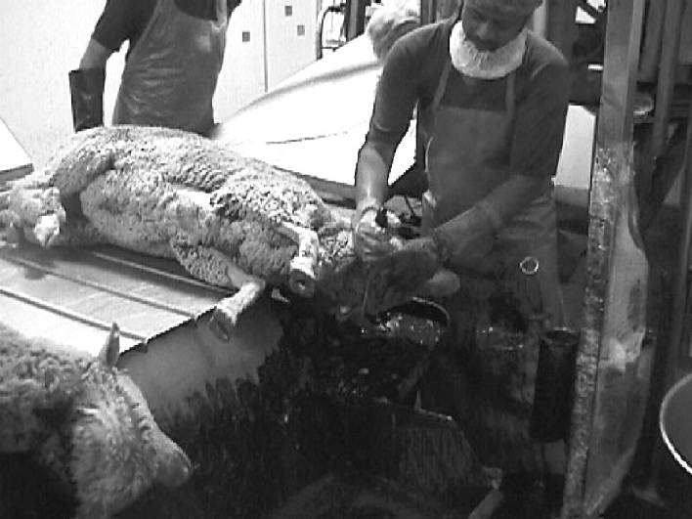
Halal slaughter of sheep
© Wodonga Institute of TAFE
Oesophagus plugs
It is important to seal the weasand or oesophagus so that stomach contents (ingesta) do not leak out and over the carcase prior to evisceration. To stop this an oesophagus plug is put into the weasand and pushed up to the opening of the stomach. This plug is put in prior to bleeding the animal and forms part of the Halal slaughter procedure documented in the company’s work instructions.
Bleeding cattle.
The Halal slaughter of cattle requires a transverse cut after the beast has been checked for an effective percussive or electrical stun. The cut involves a deep transverse cut from ear to ear immediately behind the jaw but above the Adam’s Apple. The cut should sever all the soft tissues including the carotid arteries, jugular veins, weasand and windpipe or trachea, down to the spine immediately behind the base of the skull. The cut should be made in a single stroke and the knife should not be lifted. The knife must be sharp to minimise constriction of the muscular layers of those arteries. The bleeding should be spontaneous and complete.
The name of Allah should be mentioned over the animal in the following way while slaughtering the animal, “Bismillah, Allahu Akbar” (“In the name of Allah, Allah is Great”).
As with sheep, the cut on cattle must not be made lower down the neck after reversible percussive stunning or head only electrical stunning. This is because when the cut is made lower down the neck, the arteries could retract into the neck wound and clot. If this happens, the process of bleeding is slower.
This is a particular problem in cattle where blood flows through the vertebral arteries at the back of the neck and this flow will increase if the neck wound clots. These vertebral arteries will provide an alternative source of blood to the brain. If this happens, cattle may recover sensibility. To ensure this does not happen in cattle the transverse cut is usually followed by a thoracic stick.
At this stage the weasand may be rodded, and a clip applied to the weasand, or an oesophageal plug inserted. This stops the carcase becoming contaminated with ingesta.
Thoracic stick
Thoracic sticking involves making an incision or cut into the thoracic inlet. It is normally only conducted on cattle. This severs the major blood vessels just in front of the heart. The maximum blood flow is achieved by using a sharp knife and, after the initial stab incision, curving the knife downward and across the thoracic inlet. This severs the brachio-cephalic artery.
This method of sticking cattle/calves ensures that the major trunk vessels are cut closer to the heart. These vessels supply blood to the head, neck and forelegs. This ensures that the blood flow to the brain via the vertebral artery is stopped, preventing the animal from regaining consciousness.

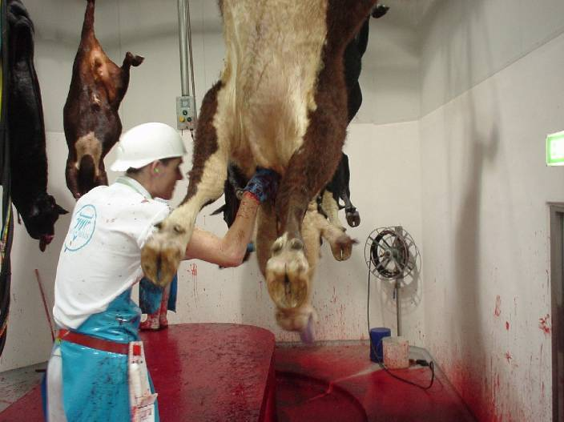
Sticking cattle
© MINTRAC
Thoracic sticking may require a longer than normal sticking knife to sever the blood vessels close to the heart.

Why is a quick, spontaneous and complete bleed important?
It is important that the bleeding out of the animal takes place immediately after stunning, so that:
- the onset of brain death is rapid
- the animal won’t regain consciousness in the case of reversible stunning, causing animal welfare, WHS, quality and hygiene sanitation problems
- the still functioning heart and circulatory system can assist with maximising the bleed out of the carcase.
Even under ideal conditions only about 50% of the blood will be removed from the animal at bleeding. The remaining blood stays in the carcase, mainly in the viscera.
It is important to have only trained and skilled Halal slaughterers performing the sticking operation. They must completely sever the blood vessels so that there is no chance of the animal regaining consciousness prior to brain death. Unskilled labour or blunt knives can cause unnecessary suffering and affect food safety and product quality.
Animals must be dead before processing begins. An animal regaining consciousness on the chain is also a major WHS hazard.
How are Halal and non- Halal carcases identified and recorded?
Halal meat products mut be clearly identified by stamping or attaching labels in accordance with the plants Approved Arrangements. Likewise, records must be kept for each day’s Halal production.
Once Halal carcases are boned and packed in cartons these cartons will be labelled to show it is Halal certified. In chillers and freezer Halal product must be segregated from non-Halal product.
Product (carcase and viscera) may be non-Halal for a number of reasons including:
- product from an animal killed by the stunning process
- product from a diseased animal
- product from an animal slaughtered by a person other than a registered Islamic slaughterer
- a non-Halal species such as pork
- product that had been in contact with a non-Halal product.
If a carcase or viscera is non-Halal it must be segregated from Halal product. The product must be tagged/labelled/ stamped so that it can be identified. It must also be stored away from Halal product, so it does not make contact with Halal product.

E | How is equipment prepared for use and stored?

Equipment is ready to use and in good condition when it is:
- clean
- sharp (if applicable)
- in good working order.
All equipment must be clean before starting work. Clean equipment avoids contamination and cross-contamination.
All equipment must be cleaned using approved cleaning agents and according to your workplace instructions.
Knives and equipment should be sterilised between carcases.
Sharpen knives and other equipment before starting work. They must be kept sharp during operations so that you can perform your task efficiently and safely. Knives used to stick livestock should be sharpened to workplace requirements to ensure an effective and humane sticking is carried out.
The operation of any other equipment, such as hoists, should be checked before you start work. This is so that you know everything is in good working order.
It is important that you know who to report any equipment problems to. Then the equipment can be cleaned, repaired or replaced promptly so that production is efficient, and the equipment is safe to use.
The workplace instructions for the preparation and operation of equipment must be followed.
Halal slaughterers also have additional responsibilities to ensure their knives are sharp and their equipment and personal equipment stored in accordance with the AIO’s Approved Arrangement.
What are the main WHS risks you might need to consider when bleeding animals?
Some common WHS hazards that you may come across during the sticking process are:
- knife cuts
- sprains and strains through:
  - ‘Overuse syndrome’ from repetitive knife movements and blunt knives
  - frequent gripping and pulling
  - pushing, pulling, lifting, twisting, and bending
- zoonotic diseases, i.e. brucellosis, Q fever
- slips, trips, and falls
- injury by using equipment such as electric hoists
- burns and scalds from sterilising equipment
- animals falling and/or kicking due to ineffective stun
- falling shackles or chains
- confined spaces
- unstunned animals escaping.

WI | How can WHS risks be reduced?

As well as your employer having a responsibility to make sure that you have a safe workplace to work in, you, as an employee, have a responsibility for your own and others' safety and wellbeing. You must report any existing hazards or potential hazards to your WHS representative or appropriate personnel, as required in your WHS policy.
To be able to do these things, you must know and follow your work instructions.
By following your workplace WHS policies and procedures and actively taking part in accident/injury prevention, you will reduce the very common injuries in the meat industry, i.e. knife wounds, sprains, and strains. And this will keep you safe and reduce the burden of the high cost of insurance premiums on your employer.
Some examples of your workplace WHS policy and procedures that you should be aware of and apply are:
- accident prevention
- emergency procedures in case of injury
- Personal Protective Equipment (PPE)
- equipment malfunction procedures
- electrical fault procedures
- emergency evacuation procedures.
Personal Protective Equipment (PPE)
Personal protective equipment to be used will be set down in the work instruction and WHS procedures. PPE may include:
- protective hand and arm covering
- protective head and hair covering
- head wear
- coat and apron
- work safety or waterproof footwear
- protective boot covers
- ear plugs/muffs
- eye and facial protection
- waterproof clothing.
Knife cuts
To prevent an accident/injury in your workplace from knife cuts, your knives must be handled, used, maintained, and stored correctly. For more details, refer to the training materials for AMPCOR204 Follow safe work policies and procedures.
Strains and sprains
To learn how to prevent strains and sprains, refer to the training materials for AMPCOR204 Follow safe work policies and procedures.
Emergency procedure if an animal escapes
It is important that you know what to do if an animal escapes in the sticking area (especially cattle) and how to raise the alarm.

WI | What are the hygiene and sanitation requirements when bleeding?

Hygiene and sanitation requirements have been covered in detail in the training materials for AMPCOR202 Apply hygiene and sanitation practices. During the bleeding process, you will need to know and follow the hygiene and sanitation requirements set out in your work instruction and SOPs for hygiene. For your own health and safety and of the product it is important you follow these procedures.
What are the possible sources of contamination?
Meat is a high-risk product as it is an excellent medium for bacteria to survive in and multiply. This is because it is moist, warm and provides food for the bacteria. It is important that all necessary steps are taken to avoid any contamination of carcases.
Contamination can occur if hands, equipment, and clothing are not cleaned according to the work instruction and the correct procedures for sticking are not followed.
The main sources of contamination at sticking are:
- hair/wool
- blood
- ingesta
- faeces
- dust and dirt.
How can these sources of contamination be avoided?
You will need to be aware of the contamination hazards in your workplace, the control measures that you must follow and corrective action you must take.
Following is a list of ways that you can control contamination hazards.
Faeces
Faeces may contain the harmful pathogenic bacteria E.coli. Therefore, faecal contamination of the carcase should be avoided at all costs.
At the point of stunning, a small piece of faeces is invariably extruded from the anus. With cattle this should be washed off before hoisting the animal. Only a minimum amount of water should be used so that drip from this area onto the stick wound is minimised at hoisting.
Cattle can also be contaminated with faeces during the stunning process if the interior and floor of the knocking box are contaminated. It is important to make sure the box is regularly hosed out.
Ingesta
Ingesta is the semi-digested contents of the stomach and weasand. It may also contain harmful bacteria. Ingesta can contaminate carcases, equipment and personnel if the animal vomits up during the stunning or hoisting operation. Care should be taken during these operations and correct workplace procedures should be used at all times.
Ingesta contamination can be markedly reduced by applying oesophageal plugs through the mouth, while the animal is stunned and lying on the dry landing area and this procedure is used in some plants.
Grease, dust and dirt
Grease, dust and dirt can cause contamination. It can be spread from animals and/or fittings to equipment and personnel in the stunning/sticking area.
Equipment and machinery should be monitored to ensure that grease contamination is avoided.
Where appropriate, stock should be worked to ensure dirt and dust contamination is minimised. If the knocking box or associated equipment becomes contaminated with dust or dirt during operation, then it must be hosed down.
The maintenance program at the individual work site needs to ensure that machinery and equipment is monitored and maintained. The individual operator should regularly check that grease contamination is being avoided.
Problems from chain fallout rail dust, grease and condensation should be reported promptly to supervisors to avoid the ongoing contamination of hides/pelts and carcases.
.
People deliberately causing unnecessary pain to animals’ risk being prosecuted.

Activity suggestion: Restraining, stunning and sticking for Halal slaughter
Materials and specialised personnel
Access to slaughter floor.
Workplace procedures/instructions for handling animals.
Personal protective equipment (PPE).
Copies of relevant work instructions and SOPs.
Veterinarian on site.
Method
Invite the Quality Assurance Manager or Slaughter Floor supervisor and the AIO’s representative to explain the stunning and sticking procedures and why compliance is important for the company, including:
- prevention of undue suffering
- legal requirements.
Discuss the meat quality implications of poor handling techniques.
Explain the stun/stick intervals for the various types of stock and how this is monitored. Explain the stunner’s responsibilities to pace the stunning with sticking rate.
Explain and demonstrate how to check for an effective stun.
On the floor, ask the trainee to monitor the stun/stick interval for 10 bodies and discuss compliance with workplace requirements. Highlight how the stunner checks for an effective stun.
Trainee activities
Ask the trainee to check the stunning of a number of animals and get them to explain what signs indicate an effective stun.

Bibliography
These publications were used to develop this training material.
Agriculture and Resource Management Council of Australia and New Zealand, AS 4696:2007 Australian Standard for the hygienic production and transportation of meat and meat products for human consumption, CSIRO publishing, Collingwood, Vic.
Agriculture and Resource Management Council of Australia and New Zealand, Australian Standard for Construction of Premises Processing Meat for Human Consumption, 1995, CSIRO Publishing, Collingwood, Vic.
Andriessen, E.H. 2001 Meat Safety Quality and Veterinary Public Health in Australia, fourth edition, Penny Farthing, Port Adelaide.
Australian Meat Industry Council (AMIC) Industry Animal Welfare Standards Livestock Processing Establishments – Preparing Meat for Human Consumption: third edition, 2020, Australian Meat Processor Corporation (AMPC) Ltd.
Export Control (Meat and Meat Product) Rules 2021
Standing Committee on Agricultural and Resource Management, Australian Code of Practice for the Welfare of Animals at Abattoirs: No 10, 1998, CSIRO Publishing, Collingwood.
Assessment materials for AMPA3015 Perform animal slaughter in accordance with Halal certification requirements
Selecting and briefing Workplace Referees
Evidence is often collected by the assessor. However, other people (third parties)—such as supervisors, trainers, team members, clients or consumers—can report what they see or hear to the assessor. Evidence collected in this manner is called ‘third party evidence’.
Involving a Workplace Referee in the collection of evidence allows assessors to gather authentic and valid evidence in difficult circumstances in a cost-effective way.
In the meat industry it is common to use Workplace Referees for evidence-gathering in cases where workplace evidence is required, but where it is not possible for the assessor to directly observe the learner at work. For example, in cases where:
- the presence of an observer may compromise workplace safety, or
- where work activities involve issues of student confidentiality and privacy.
The use of third-party evidence is also a valuable strategy for collecting evidence of ‘everyday performance’ rather than performance carried out as part of the formal assessment process. It also attests to the student ability to conform to requirements over a period of time
If an agreement has been reached with a Workplace Referee to collect evidence to complement other evidence gathered by the assessor, it is still the role of the assessor to make the judgement about whether competency has been achieved. Remember that the workplace referee needs to be inducted and briefed about the role.
What to consider when using a Workplace Referee
The RTO should first determine that it is appropriate to involve a Workplace Referee in the collection of evidence.
The RTO must then ensure its assessment processes lead to the collection of quality evidence.
The RTO must provide sufficient guidance to both assessors and the Workplace Referee by addressing the following requirements.
- Provide assessors with comprehensive guidance about how to select the best Workplace Referee: the appropriate person to observe or report on the performance of the learner is someone who is in a position to make a valid comment on the learner’s performance, for example, a line manager.
- Provide quality materials for collecting evidence: these materials must seek/solicit/allow for feedback that is directly related to the relevant unit(s) of competency on the learner’s performance.
- Provide Workplace Referees with comprehensive information about their role in the evidence-gathering process: this includes providing clear guidance and instruction on when, how, how often and over what period of time the evidence is to be collected. The materials must explain the form in which the evidence is to be collected—for example, a structured third-party report or an observation checklist that clearly identifies what was observed or performed.
- Obtain confirmation that the Workplace Referee understands their role in the process: this should include confirmation that the Workplace Referee has agreed to participate in the evidence gathering process and that they understand when and how to collect evidence.
- ‘Interpret’ training package information to be relevant to the Workplace Referee: Training package Units of Competency describe work outcomes. Each of these Units describes:
  - a specific work activity
  - the conditions under which this work activity is conducted, and
  - the evidence that may be gathered in order to determine whether the activity is being performed in a competent manner.
Training package information is written to guide assessors in making competency judgements, and the language is sometimes complex. Therefore, the behaviours and/or knowledge that the Workplace Referee is being asked to collect evidence of must be ‘interpreted’.
The ‘interpreted’ information should describe how a competent worker would perform the task described by the unit. This may include describing how a competent worker might meet standards in effect in the workplace (for example, standards relating to the speed or amount of work to be undertaken or other quality measures).
- Set requirements for assessors in confirming the authenticity and currency of evidence provided by a candidate: That is, setting requirements for assessors to confirm that evidence is the candidate’s own work.
Recording assessment information
Notations
If using a checklist, it is recommended that the assessors make notations to record aspects of the assessment such as:
- date, time and location
- context – e.g. product, species, production speed
- notes about specific performance of the trainee – areas of skill; errors; confidence
- notes from the trainee’s answers to questions.
Photos
Photographs can be a useful visual record of an assessment. When using photographs, consider the following:
- the trainee must give permission to be photographed
- if the location is identifiable, then it is appropriate also to seek permission from the enterprise
- ensure the trainee is identifiable
- photograph the final product as well as aspects of the process – as relevant to the Unit
- dating and recording the photograph.
Recordings
Live recordings can also be a useful form of evidence. When using live recordings consider:
- the trainee must give permission to be recorded
- if the location is identifiable, then it is appropriate also to seek permission from the enterprise
- the safety and location of the person filming
- dating and recording the film
- storage and security of the film.
Addressing the Language, Literacy and Numeracy (LLN) requirements of this unit
Language, literacy and numeracy requirements will require the candidate to:
- correctly use measuring equipment for voltage and/or gas levels, as applicable
- report equipment faults according to workplace requirements
- work effectively as an individual and as part of a team.
Reasonable adjustment
‘Reasonable adjustment’ is a term used in the education, employment and VET sectors to refer to any modification made to the learning environment, certification requirements, training delivery or assessment method used to help students with disability to access and participate in education and training on the same basis as those without disability.
RTOs are obliged by law to make reasonable adjustment to ensure maximum participation of students with disability in teaching, learning and assessment activities. This includes:
- ensuring that course activities are sufficiently flexible
- providing additional support where necessary
- offering a reasonable substitute within the context of the course where a student cannot participate.
Numerous resources on reasonable adjustment, published by State Governments, are available and RTOs are urged to access these resources if in doubt of their obligations.
The MINTRAC sample assessment tools
Key assessment requirements for this Unit of Competency
Assessors should note that in the transition from the MTM to the AMP versions of the Australian Meat Processing Training Package, significant changes have been made to the Assessment Requirements for this unit. They should ensure that they have downloaded a current version of the Assessment Requirements from www.training.gov.au before commencing the assessment process.
The Evidence Guide and Sample Assessment Tools provided in these materials may have slight differences from the Assessment Requirements, and assessors should ensure that their customised Assessment Tools match the current version of the Assessment Requirements from www.training.gov.au.
Are the MINTRAC sample assessment tools ‘validated’?
No. The MINTRAC sample assessment tools are just ‘samples. While they will be a useful starting point in developing your own customised assessment tools, they should never be used without modification, and should be validated as part of your own RTO validation processes.
How to use the sample assessment tools
1. Customise them to the trainee's work situation
This is compulsory and customisation may include:
- adding or removing questions
- inserting relevant work instructions
- adjusting the language to suit the individual workplace
- adding sections for additional assessors to sign off
- adjusting the assessment task to suit the learning needs of individual learners.
2. Adjust and re-check the Evidence Guide
You will need to ensure that the Evidence Guide is updated to include any changes you have made to the assessment tools.
3. Use the assessment sheet
Remember:
- record your own comments as a record of the assessment situation
- collect the relevant signatures
- retain the completed assessment sheet as part of your assessment evidence.

The Evidence Guide
The Evidence Guide provides a means of ensuring that the selected assessment tasks collectively address the Unit of Competency and the Assessment requirements. The Evidence Guide provided in these tools has been checked against the sample assessment tools contained in this document. However, before using this Evidence Guide, assessors must:
- make alterations to reflect any changes they have made to the assessment tools
- verify that the notations entered by MINTRAC are an accurate reflection of the assessment tasks.
Evidence guides
1. Prepare for Halal slaughter
Assessor:
Company/workplace:
Registered Training Organisation:
AMPA3015 Perform animal slaughter in accordance with Halal certification requirements
 |  | Workplace referee’s report | Test or quiz | On-the-job assessment with assessor observation
Elements and performance criteria
Element 1: Prepare for Halal slaughter
1.1 Identify and apply the rules and conditions required for Halal slaughter |  | X | X | X
1.2 Check workplace for hazards, identify risks and apply control measures |  | X | X | X
1.3 Prepare Halal approved equipment prior to slaughter and confirm knife is sharp, and restrainer is operational |  | X |  | X
1.4 Prepare self and equipment according to enterprise hygiene requirements |  | X |  | X
1.5 Perform stunning using stunning method and strength approved by public health and Islamic authorities |  | X |  | X
1.6 Identify animals dying before slaughter as non-Halal, and report to supervisor |  | X | X
Element 2: Perform Halal slaughter
2.1 Position animal on the left side facing Kiblah, and in a manner that confirms the slaughter is quick and pain-free |  | X |  | X
2.2 Confirm animal insensibility prior to commencing slaughter process |  | X |  | X
2.3 Follow required Halal slaughter procedures, applying one cut just below glottis in short-necked animals and severing the major vessels whilst uttering prayer |  | X |  | X
2.4 Perform slaughter process within established timeframe |  | X |  | X
Element 3: Complete slaughter operations
3.1 Clean and sterilise facilities and equipment according to workplace requirements |  | X |  | X
3.2 Identify, record and report any carcase and offal that do not meet Halal requirements, and confirm that it is segregated from Halal carcases and offal |  | X
3.3 Identify and attach labels to be used on Halal meat products |  | X |  | X
3.4 Complete post-slaughter documents within organisational timeframes |  | X |  | X
3.5 Complete equipment storage to avoid cross-contamination according to Halal requirements |  | X | X | X
Assessment requirements
Performance evidence
Candidates must demonstrate ability to:
There must be evidence that the individual has satisfactorily completed the Halal slaughter process on at least 25 animals, including:
- complied with relevant Islamic laws during the process |  | X |  | X
- completed the process within established stunning-to-slaughter timeframes |  | X |  | X
- identified non-Halal carcases and taken appropriate action with carcase(s) if they occur |  | X |  | X
- identified and taken appropriate action when Halal product has been contaminated by non-Halal product or processes |  | X |  | X
- completed post slaughter documentation, equipment cleaning and storage requirements. |  | X |  | X

Knowledge Evidence
An individual must be able to demonstrate the knowledge required to perform the tasks outlined in the elements and performance criteria of this unit. This includes knowledge of:
- requirements for certification with an Approved Islamic Organisation |  | X | X | X
- Islamic law relevant to the slaughter process |  |  | X | X
- differences between Halal and non-Halal stunning and slaughter procedures |  |  | X | X
- procedures for managing stunned animals showing signs of consciousness |  | X | X | X
- establishment hygiene and sanitation requirements during the slaughter process |  | X | X | X
- requirements for Halal slaughter and how they relate to the AS4696:2007 Australian Standard for the Hygienic Production and Transportation of Meat and Meat Products for Human Consumption |  |  | X | X
- Halal industry guidelines relating to the use of equipment and methods |  | X | X | X
- additional customer requirements for Halal slaughter, where applicable |  |  | X | X
- acceptable practices for use of oesophagus plug |  | X | X | X
- factors that render product as non-Halal, including: |  | X | X
- animals which are not permitted on the premises |  |  | X

Workplace referee's report
Trainee:
Assessor:
Company/workplace:

AMPA3015 Perform animal slaughter in accordance with Halal certification requirements
Instructions to the Workplace Referee
The Workplace Referee is an experienced supervisor or colleague of the trainee who is able to provide evidence about:
- the trainee’s ability to carry out the tasks described in the Unit of Competency at the speed and to the level of proficiency expected in the workplace
- consistency of performance over time
- application of the Employability Skills, as described under ‘Required Skills and Knowledge’.
The Workplace Referee’s Report forms an essential part of the overall assessment of the Unit and should only be completed and signed when the Workplace Referee is confident that competency has been achieved.
The Workplace Referee is encouraged to record notes and observations related to the assessment onto the recording sheet.
Information about the Workplace Referee (please print clearly)
Name
Job title
Contact number
Period of time when Trainee was observed by Workplace Referee
Evidence: | Map to E&PC | Referee’s comments:
Does the trainee consistently:
Identify and apply the rules and conditions required for Halal slaughter | 1.1  PE 1
Identify WHS hazards in the stunning area | 1.2
Identify WHS hazards in the sticking area | 1.2
Follow WHS procedures | 1.2
Prepare Halal approved equipment prior to stunning and slaughter, | 1.3  PE 1  PE 5
Check their knife’s sharpness for bleeding animals | 1.3  PE 1
Check restrainer is working prior to the commencement of stunning | 1.3
Follow personal hygiene SOP | 1.4  PE5
Store and clean equipment according to SOPs and work instructions | 1.4  PE5
Perform stunning according to work instruction and halal requirements | 1.5  PE 1
Identify animals that die from stunning and understand the reporting process | 1.6  PE 1  KE7
Identify and implements re-stun procedures | KE 4
Position animal on the left side facing Kiblah, and in a manner that confirms the slaughter is quick and pain-free | 2.1  PE 1  KE7
Confirm animal insensibility prior to commencing slaughter process | 2.2  PE 1
Follow required Halal slaughter procedures, applying one cut just below glottis in short-necked animals and severing the major vessels whilst saying prayer | 2.3  PE 1
Perform slaughter process within stun/stick interval | 2.4  PE 2
Follow work instruction for bleeding animals | KE5
Apply oesophageal plug | KE9
Follows work instruction requirements for cleaning work area/equipment and sterilising knives | 3.1  KE5
Identify non-Halal product, record and report any carcase and offal that do not meet Halal requirements, and confirm that it is segregated from Halal carcases and offal | 3.2  PE 3
Identify, records and reports non-Halal product according to work instructions | 3.2  PE 1  PE 3
Confirm segregation of non-Halal product | 3.2  PE 1  PE 3
Use stamps and / or labels to identify Halal meat products | 3.3  PE 1
Complete post-slaughter documents within organisational timeframes | PE 5
Complete required documentation | 3.5  PE 1
Follow SOP for equipment storage according to meet Halal requirements | 3.4  PE 1
Referee comment and signature: |  |  | Date:
Trainee comment and signature: |  |  | Date:
Assessor comment and signature: |  |  | Date:

On-the-job demonstration with assessor observation
Trainee:
Assessor:
Company/workplace:
Registered Training Organisation:

AMPA3015 Perform animal slaughter in accordance with Halal certification requirements
Guidance to assessors
It is expected that when conducting this form of assessment, you will observe the trainee performing the tasks associated with the Unit of Competency at least once in the workplace (or elsewhere if allowable in this Unit).
It is also expected that you will discuss the trainee’s performance either during the observance, or in a separate conversation if this is not feasible. During this conversation you will also verbally test the trainee’s underpinning knowledge and understanding of the tasks.
The assessor should make notes of the time, place, situation and actual tasks observed, in addition to the proficiency of the trainee during the period of observation.

Assessment requirements
Details of assessment
Date and time:
Location:
Tasks observed:
Evidence: |  | Map to E&PC | Referee’s comments:
Does the trainee consistently:
Identify and apply the rules and conditions required for Halal slaughter |  | 1.1  PE 1
Identify WHS hazards in the stunning area |  | 1.2
Identify WHS hazards in the sticking area |  | 1.2
Follow WHS procedures |  | 1.2
Prepare Halal approved equipment prior to stunning and slaughter, |  | 1.3  PE 1  PE 5
Check their knife’s sharpness for bleeding animals |  | 1.3  PE 1
Check restrainer is working prior to the commencement of stunning |  | 1.3
Follow personal hygiene SOP |  | 1.4  PE5
Store and clean equipment according to SOPs and work instructions |  | 1.4  PE5
Perform stunning according to work instruction and Halal requirements |  | 1.5  PE 1
Position animal on the left side facing Kiblah, and in a manner that confirms the slaughter is quick and pain-free |  | 2.1  PE 1  KE7
Confirm animal insensibility prior to commencing slaughter process |  | 2.2  PE 1
Follow required Halal slaughter procedures, applying one cut just below glottis in short-necked animals and severing the major vessels whilst saying prayer |  | 2.3  PE 1
Perform slaughter process within stun/stick interval |  | 2.4  PE 2
Follow work instruction for bleeding animals |  | KE5
Apply oesophageal plug |  | KE9
Follows work instruction requirements for cleaning work area/equipment and sterilising knives |  | 3.1  KE5
Identify, records and reports non-Halal product according to work instructions |  | 3.2  PE 1  PE 3
Confirm segregation of non-Halal product |  | 3.2  PE 1  PE 3
Use stamps and / or labels to identify Halal meat products |  | 3.3  PE 1
Complete post-slaughter documents within organisational timeframes |  | PE 5
Complete required documentation |  | 3.5  PE 1
Follow SOP for equipment storage according to meet Halal requirements |  | 3.4  PE 1
Referee comment and signature: |  |  |  | Date:
Trainee comment and signature: |  |  |  | Date:
Assessor comment and signature: |  |  |  | Date:

Test or quiz

Trainee:
Assessor:
Company/workplace:
Registered Training Organisation:

AMPA3015 Perform animal slaughter in accordance with Halal certification requirements
Information for assessors
- The test or quiz can be conducted as either a written or oral assessment depending on the Unit requirements, and context and capability of the trainee.
- This sheet should never be provided to the trainee. Assessors should use the questions to make up their own test instruments.
- The sample questions need not be used for a single test – see the customisation suggestions earlier in this document for suggestions on how to modify the test.
Assessment requirements
[insert and number knowledge evidence requirements]
Sample questions | Map to Assessment Requirements
- What is an Approved Islamic Organisation? | KE1
- What is an AIO’s role in certifying Halal Product? | KE1
- How are Halal slaughterer’s registered? | KE1
- What do you do if the stun is ineffective? | 2.2
- What are the Halal requirements for stunning? | 1.1  KE7
- How do you check for an effective stun? | 2.2
- What do you do if the stun is ineffective? | 2.2
- What are the Halal requirements for bleeding? | KE2
- What are the main animal welfare considerations of stunning? | 2.3
- What are the main animal welfare aspects of restraint? | 1.5
- Why are animals restrained? | 1.5
- What stunning practices are non-Halal | KE3
- What bleeding practices are non-Halal | KE3  KE10
- What makes a product non-Halal | KE3  KE10
- How is stunning equipment prepared and maintained? | 1.3
- Who should perform the stunning operation? | 1.3
- What are the consequences of an ineffective stun? | 2.2
- Why is it necessary to have back-up procedures? Describe the back-up procedures available in your plant. | 2.2
- What are the WHS hazards associated with stunning? | 3.2
- Select three of these hazards and explain how they can be reduced. | 3.2
- Identify three potential causes of contamination and cross-contamination during stunning. | 1.5
- Explain how each of these may be reduced. | 1.5
- Explain the impact ineffective restraint and stunning may have on product quality. | 1.5
- How are animals bled to meet Halal requirements? | 2.1  2.2  2.3  KE7
- What prayer is said as part of Halal slaughter? | 2.1
- What are the stick/stun intervals and why are they important? | AR10
- What are the hygiene and sanitation requirements when bleeding? | KE 5
- What are the possible sources of contamination? | KE5
- How can these sources of contamination be avoided? | AR14  1.6KE5
- What are oesophagus plugs used for?  . | KE9
- How are oesophagus plugs inserted? | KE9

Answer sheet (for assessor use only)
Note: the suggested answers are provided as a guide only. It is not mandatory that every aspect of the suggested answer be covered by the trainee and the assessor should use their own judgement to determine whether the question has been sufficiently and accurately answered. Remember also, that trainees may propose answers that are different to what has been suggested here – again these should be considered on merit.
Question | Suggested answer
- What is an Approved Islamic Organisation?
- What is an AIO’s role in certifying Halal Product?
- How are Halal slaughterer’s registered?
- What do you do if the stun is ineffective?
- What are the Halal requirements for stunning?
- How do you check for an effective stun?

- What do you do if the stun is ineffective?
- What are the Halal requirements for bleeding?
- What are the main animal welfare considerations of stunning?
- What are the main animal welfare aspects of restraint?
- Why are animals restrained?
- What stunning practices are non-Halal?
- What bleeding practices are non-Halal?
- What makes a product non-Halal?

- How is stunning equipment prepared and maintained?
- Who should perform the stunning operation?
- What are the consequences of an ineffective stun?
- Why is it necessary to have back-up procedures? Describe the back-up procedures available in your plant.
- What are the WHS hazards associated with stunning?
- Select three of these hazards and explain how they can be reduced.
- Identify three potential causes of contamination and cross-contamination during stunning.
- Explain how each of these may be reduced.
- Explain the impact ineffective restraint and stunning may have on product quality.
- How are animals bled to meet Halal requirements?
- What prayer is said as part of Halal slaughter?
- What are the stick/stun intervals and why are they important?
- What are the hygiene and sanitation requirements when bleeding?

- What are the possible sources of contamination?
- How can these sources of contamination be avoided?
- What are oesophagus plugs used for?
- How are oesophagus plugs inserted?

Record of completed assessment
Trainee:
Assessor:
Company/workplace:
Registered Training Organisation:

AMPA3000 Stun animal
Elements and performance criteria | Assessor’s initials |  | Date
Element 1
1.1
1.2
1.3
Element 2
2.1
2.2
2.3
Element 3
3.1
3.2
3.3
Assessment requirements
Performance evidence
Knowledge evidence
Compliance with Company requirements
Complies with company work instructions and/or standard operating procedures.

Forms of evidence used to assess competence
Context of assessment (if applicable)
Equipment/machinery:
Species:
Technique:
Signatures
This trainee has been assessed according to the requirements of the unit of competence identified above. Competence has been demonstrated.
Trainee sign off: |  | Date:
Assessor sign off: |  | Date:

The information contained in this section is based on an Australian Skills Quality Agency (ASQA) Fact Sheet: Using third-party evidence to assess competence. Version 1.0 February 2013

